Department of Information Technology, College of Engineering and Informatics Industry Stream Project

Industry Stream Project Student: Eanna Hegerty (12232385)

Supervisor: Enda Barret

Date of Submission:

Table of Contents

Introduction: 3

Document Overview 3

Personnel Statement: 3

Personnel Goal and Objectives: 4

Stakeholders: 4

Initial Statement of Problem & Advancements 5

Additional technologies incorporated 5

Software Purpose 6

Project Requirements: 6

Initial Requirements 6

Added Requirements 6

Key Challenges 7

Project Success & Evaluation Criteria 7

System Definition: 7

Development Life Cycle Methodology 7

System Design: 7

Design Pattern: 7

Technology Outline: 7

Research & Training: 7

System Overview: 8

Devolvement Practises & Processes 8

General Constraints: 8

Testing: 8

Future development 8

Technologies Used 8

# Introduction:

## Document Overview

This document will outline all the activities, goals, experiences and processes that were undertaken throughout this project. By reading this document the reader should be able to gain a full understand the stand point in which the me the developer was at when under taking this project and the journey I took to till creating this document. The reader should also have a good understanding of how the technologies and design pattern used during the creation of this web-application. Most importantly the reader must be able to understand the premious of the application and it main functional activities.

# Software Purpose

In today’s world companies and individuals are demanding more from their software.

The general public can now access their personnel email and documents anywhere they have a browser. Gone are the days of downloading your email too your desktop, or having a vital piece of software on one computer in one location. Applications must be real time, available across multiple devices, portable device friendly and accessible on the go. This is no truer than with top level management; management should be able to view sales analytics, order detail, customer data on the go. track sales, stock levels, employee performances, best/worst customers, top selling products, order information, delivery status and even request the development of a brand new report or analysis’s all from the comfort of home or on the go.

As it stands this demand has not been meet by most head Office software for retail industry. Head Office software is often located on a server in an office space. So what does this outdate practise mean for the clients

* Buying an expensive server
* Maintaining physical server upkeep
* Client is tied to accessing Head Office software in one location
* Poor physical environment for server
* No back-up plan, if server dies user is without reports for day if not weeks

So how do we address this issue; Hego analytics is how. Hego analytics software is hosted on the cloud with AWS, no need to buy a physical server and place it on site. This also means users have accesses to reports anywhere anytime as long as they have a browser and have internet access. Hego analytics software is device friendly so users can view reports on the go from their personnel devices. Hego clients have option of requesting additional reports via the ticketing service, where they can view update the ticket status. Hego databases uses MongoDB database which mean that reports & analysis are much quicker than traditional sql databases. Because of our partnership with AWS your database and HO application is guaranteed 99.99% uptime. Database mirroring is also an option that is available too out users meaning users do not have to fear losing important information if the server fails.

|  |  |  |
| --- | --- | --- |
|  | Competitors | Hego Analytics |
| Software availability | 1 location | Any where |
| Server Purchase & maintenance | Yes | No |
| Reports & Analytics speed | Slow | Quick |
| Backup security | USB key | Automatic |
| Online Ticketing Service | No | Yes |
| Visual Analytics | No | Yes |
| Guaranteed application uptime | ?? | 99.99% |

# Personnel Statement:

Before undertaking the industry project my prior experience in technologies were very limited. I had a good understanding of MySQL and had just done a full semester of Java and internet programming (html & css). I had never built any application from start to finish or had any real programming experience outside of what I had learnt from first semester 1. I had never written a line of code in JavaScript and by the end of the project I had created a fully functioning web application that not only used JavaScript, D3.js and Angular.js in the front end I also created a backend that consisted of Node.js, Express.js, Passport.js and Mongoose.js all of which are either libraries or frameworks for JavaScript. This along with creating a mongo database based on NoSQL again I had never seen before. These technologies were all self-taught and used to create an application that include several instances of RESTFUL CRUD API’s and hosted on a virtual machine on the AWS cloud. I found this industry project vital invaluable in regards confidence to tackle problem, teaching myself new languages and concepts and hopefully preparing me for the working world

# Personnel Goal and Objectives:

My personnel goal and objects for this project from the outset were:

1. To build a product that achieves and surpasses my functional requirements.
2. To incorporate as many technologies that I will be using during my internship at AltoCloud.
3. To develop my understanding of design patterns.
4. To become experienced in as many real world third party development software.
5. To broaden by general information technology knowledge.
6. To implement testing, as to prepare me for real world development.

# Stakeholders:

The stakeholders involved in this industry project are as follows:

1. Developer: Eanna Hegerty
2. Supervisor: Enda Barret
3. Industry Partner: AltoCloud
4. Course Administrator: Enda Howley
5. University: NUIG
6. End Users

# Statement of Problem.

In my initial Project Definition Document I defined the below statement of problem:

“Create an online application that will allow users/retail staff to view reports generated through analytics in regards to current stock levels, orders, employee details etc. Different users should be able to view different reports depending on their administration rights or personally assigned reports.”

At the time of writing this document I have not only solved the above problem but I have addressed the following issues also.

The application should be fully mobile friendly, incorporate a single page application design, allow users to edit reports once retrieved and display analytics in a graphic form.

# Industrial project Technologies & concepts

From the outset of my industry project both my industry partner and supervisor had several technologies and concepts that the system must incorporate during the development process. I am glad to say I incorporate all the technologies & concepts required of me. In addition to these requirements I added several of my own which are listed below.

## Company requested technologies & concepts

|  |  |
| --- | --- |
| Technologies | Incorporated Yes/No |
| AWS (Amazon web Services) | Yes |
| Ubuntu OS | Yes |
| Node.js | Yes |
| RESTful APIs | Yes |
| Virtual Machines | Yes |
| NPM | Yes |

## Supervisors requested technologies & concepts

|  |  |
| --- | --- |
| Technologies | Incorporated Yes/No |
| MongoDB | Yes |
| Express.js | Yes |
| Angular.js | Yes |
| D3.js | Yes |

## Self-imposed technologies & concepts

|  |  |
| --- | --- |
| Technologies | Incorporated Yes/No |
| GitHub | Yes |
| Putty | Yes |
| WinSCP | Yes |
| Postman | Yes |
| Bootstrap | Yes |
| VMC (view model controller) | Yes |
| Single page application | Yes |

# Requirements

## Initial Requirements

When Starting my industry project I set the below requirements for my application

1. Create a web application that can be accessed from distributed devices.
2. Create a web application is bout desktop and mobile friendly.
3. Create api’s that Created, Read, Update and Delete from a database
4. Host the Web Application with AWS on an Ubuntu instance
5. Construct the application with the MEAN stack

### Additional Requirements

During the devolvement of any software project the requirements of the project change and expand. This devolvement’s lead to the self-imposed additional requirements:

* The application must be a single page application
* The application must be built using source code management tools that a hear to dev-ops best standards.
* The application must be built using the MVC design pattern

The web application must use docker.js for easy of movement

|  |  |
| --- | --- |
| Primary Requirements Achieved | Achieved Yes/No |
| **Create a web application that can be accessed from distributed devices.** | **Yes** |
| **Create a web application is bout desktop and mobile friendly.** | **Yes** |
| **Create api’s that Created, Read, Update and Delete from a database** | **Yes** |
| **Host the Web Application with AWS on an Ubuntu instance** | **Yes** |
| **Construct the application with the MEAN stack** | **Yes** |
| Secondary Requirements Achieved |  |
| **The application must be a single page application** | **Yes** |
| **The application must be built using source code management tools that a hear to dev-ops best standards** | **Yes** |
| **The application must be built using the MVC design pattern** | **Yes** |

# Key features of the application

1. **Single a page application**
2. **Several Create , Read, Update, Delete api’s included**
3. **Several analytical api created and results displayed in chart form**
4. **Secure login system**
5. **Application is built in MVC design pattern**
6. **Hosted on virtual machine on the cloud**
7. **Full MEAN stack implementation**
8. **Personnel profile screen**
9. **Different layer of access right for users (api’s & pages)**
10. **Fully mobile and desktop friendly**

# Technologies

In this section I will walk through the man technologies I used throughout my project. I will give a brief explination of the technologies themselves and their role within my application.

### Stack:Mean

### Node.js

“Node.js® is a JavaScript runtime built on Chrome's V8 JavaScript engine. Node.js uses an event-driven, non-blocking I/O model that makes it lightweight and efficient. Node.js' package ecosystem, npm, is the largest ecosystem of open source libraries in the world”( <https://nodejs.org/en/>)

Above is an explanation of node.js from the nodejs.org website. My understanding of node is that it is a runtime environment that allows JavaScript to be read on the server and not on client browsers and JavaScript traditionally does. This is made possible because node.js consists of Chrome's V8 JavaScript engine that is open source and runs in chrome browsers to render JavaScript.

Benefits of node.js

* Node.js is consider to be a cross platform application, meaning that it can be used on multiple different OS system, including the big three, IOS, Linux and Windows.
* Node.js has vast library of JavaScript modules, making it easy to develop web application quickly. Node.js library has come about via its open source nature, leading to many contributors and in turn its growth in popularity since its launch in 2009.
* Node.js is Asynchronous and Event Driven, which means for applications built on node.js do not wait for response after making api request (querying a database), blocking the entire application from carrying out requests. But instead node makes api’ request and moves onto the next request and uses an event loop that listen for response and handles then handles them as the return.
* Because of it Non-blocking nature node.js only uses 1 thread and can handle a large number of requests compare to tradional server technologies like apache server (<http://www.tutorialspoint.com/nodejs/nodejs_introduction.htm>).

The role in which Node.js played in my project is simple; it allowed me to create my application using only JavaScript, JavaScript frameworks and libraries. Node.js also made it easy for me to build my single page application easily and elegantly because of the speed of which it work’s. Because of its platform portability it meant that moving my application from a window environment to an Ubuntu instance in the cloud was much easier than first expected. The most important role Node.js played in my application was that it allowed be to use express.js framework in which I built my server.

### Express .js

“Express is a minimal and flexible Node.js web application framework that provides a robust set of features for web and mobile applications.”(http://expressjs.com/)

Above we see the explanation expressjs.com of express.js. Express.js is the standard JavaScript framework for building the backend of web applications in the node.js runtime environment. Express.js can be used to the server aspect of an application, quickly and easily receive http request for pages and sending pack response. Express.js is also used to create api’s for web applications using middleware and it’s ability to handle http requests

”Middleware functions can perform the following tasks:

* Execute any code.
* Make changes to the request and the response objects.
* End the request-response cycle.
* Call the next middleware in the stack.
* <http://expressjs.com/en/guide/writing-middleware.html>”

In my application express was used to build by api’s that queried the database and send back responses to the client dependent on the result of the query. I will go into future details on how I used express.js will walking through the back end code.

### MongoDB

MongoDB is a NoSQL database, which means that is does not follow the traditional SQL relational database model. As it name suggests it does not contain any SQL or maintains and relationships between tables or even have table. MongoDB is made of collections (compared to tables), documents (rows) and fields (columns)

MongoDb stores its data in BSON which are JSON like documents; this similarity makes mongo very easily applications that use JSON data. Mongo like Node.js is open source and cross platform application causing it popularity in recent years grow rapidly. Because it does not adhere to strict relation database rules MongoDB is considered very flexible, documents stored within the same collection can have different field because they are indepent.

MongoDB was used to store my table information and its schema structure was mapped to mongoose (a package used to query mongodb from the application).

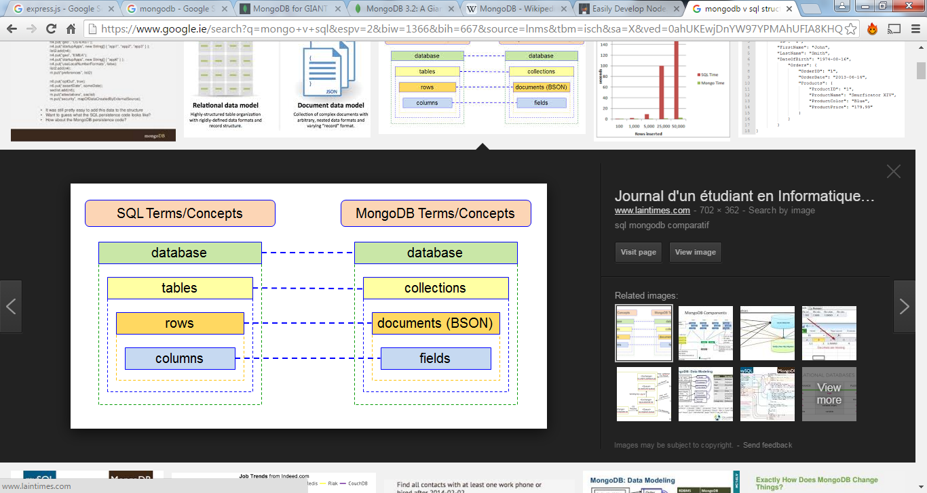

<http://www.laintimes.com/>

### Angular.js

.

The final part of the Mean stack is angular, which was used on the client side. Angular.js is a JavaScript framework commonly used on single page application. It is used to manipulate the view (GUI) by using MVC design pattern on the front end. Angular treats the GUI as the view, the model as it’s $scope variable and the controller which manipulate its assigned view.

Key parts

• AngularJS module

• AngularJS controllers

• AngularJS Directives

### AWS

Amazon Web Services commonly referred to AWS is a cloud platform offered by Amazon.com. AWS offers it customer a quick access to the cloud in regards to hosting, developing or storage. It most popular package is its EC2 (Amazon Elastic Compute Cloud) package which we will be referring too today. EC2 service allows user to create virtual machines from images, which are snapshots of virtual machines along with all their software configurations and data storage. ES2 allows user to scale up or down the amount storage or instance running very quickly; and in turn change the amount charge by AWS.

I used AWS’s EC2 to create an VM of an Ubuntu instance, from this instance I was able to define the ports in which I needed access too (port 80 http, port 22 for ssh). Along with this functionality I set up the pair key authentication which was need to communicate with my VM via PuTTY & WinSCP. The lack of an interface for MV meant that I needed to lean bash commands to install the required software to run my application. Using Putty I installed Node.js and Mongodb, following this I used NPM to installed the required packages needed to run my application. I used WinSCP to transfer my application files and my database which was stored in csv files. Finally when all configuration was setup I stored my Ubuntu instance as an image and carried on development on my application locally, transferring each new interaction to the cloud to carry out testing.

# Bracket

Brackets was used to develop my application locally. I originally used JetBrains Webstorm but found the configuration’s processes troublesome and the amount of boiler code created crippled to my understanding of core node.js, express.js and MVC concepts. At this point I move over to using Brackets as it a very simple to use text editor and forced me to learn and understand the code that Webstorm had created for me.

### Postman

Postman was an integral part to the construction of my application, it allowed me to test my application throughout the development life cycle. Postman can be used to send http request to endpoint with a wide range of being sent in the body and header. This aspect of postman alone helped me greatly as it aloud me to develop api’s and test them before joing them up with other aspects of my application, such as my angular application. Postman also allows user to create predefined test of api’s and will tell the developer if the test either failed or pass. I found this tool unparalled when carrying white box testing of software.

# GitHub

GitHub is a version control system, that allows developer to store version of software locally (desktop) or on their personnel GitHub repository. GitHub track changes made to documents and allows role to previous version on command. GitHub is based on Git which is a command line tool for version control. GitHub was used in this project to store and track different versions of my software and roll back changes as needed. Its online repository was also used as it safeguarded against hard drive failure.

# Main challenges

The main challenges I meet during my project was the lack of familiarity with most of the technologies used in my web-application. I have listed below all the application used that I had either no prior experience with or even knowledge of before undertaking this project.

## No prior experience with:

* JavaScript
* Angular
* Pair Key Authentication
* MongoDB
* Virtual Machine
* Angular

## No prior knowledge of:

* Node.js
* Express.js
* AWS
* MVC

## How did I overcome these challenges

To overcome my lack of experience and knowledge with the above concepts and technologies I used several strategies.

* Online courses
* Group discussions (class mate brainstorming)
* Self-discovery (experimenting & testing)
* Course material
* Online forums

# Research & Training:

I undertook extensive training prior and during development of this industry project. Before I started coding my project I undertook getting familiar with AWS (Amazon Web Service), as it was one of the requirement of my project that my application would be hosted on this cloud hosting vender. I spent the best part of 2 weeks with this application and the surrounding concept and supporting applications. Some of these research activities include setting up an AWS account, getting familiar it’s GUI. Also learning concepts and technology such as virtual machines, images, PuTTY, WinSCP, instances, public and private key authentication. All of the above I used prior to coding and hosting my project which allowed me to easily carry out hosting my application 3 months later after it was developed.

Prior to development I also under took training from several online services such as the New Boston website (Node.js & Mongodb), Udemy (Angular, Node.js and JavaScript) ??. Along with this training I also took part in serval YouTube courses in order to further my knowledge. In particular the most beneficial resources I found was the Udemy course I under took which I total took 20 hours of training material and easily another 30 hours of implementing, exploring and understanding the material.

# System Functional Development

The web application has been through several different functional iterations that are described below.

# Interaction 1

The applications first iteration was focused on

* Creating the Mongo database
* Creating basic CRUD api’s using express
* Creating a login system
* Creating basic ejs pages to enhance api functionality

# Interaction 2

The applications second iteration was focused on

* Creating more CRUD api’s
* Improving the user interface
* Creating the Analytics api’s and charting the information
* Creating the administration view for api’s requesting
* Changing the login functionality to adhere to level of administration rights
* Single page application & large amount of angular functionality

# Interaction 3

The applications third iteration was focused on

* Personnel profile access functionality
* Adding personnel reports functionality
* Refactoring and enhancing api’s
* Refactoring and enhancing angular

# GUI Development

The GUI design was a constant development throughout project. I believe there have been 2 major iterations that have resulted in this final GUI since the creation of the prototype.

1. The prototype was a low fidelity design created requirements document.
2. The first iteration came about through developing the application from day to day activities
3. The second iteration came about via usability testing that I had carried out by Caroline Wythe (HR manager in Jury’s) & Conor Killilea (ex- banker). Both of which had extensive experience with web-application for industry usage. I took notes and asked questions and the two participants used the system and gave feedback on how it could be improved. The feedback also pushed me to make the application a fully single page application.

# Low fidelity Design

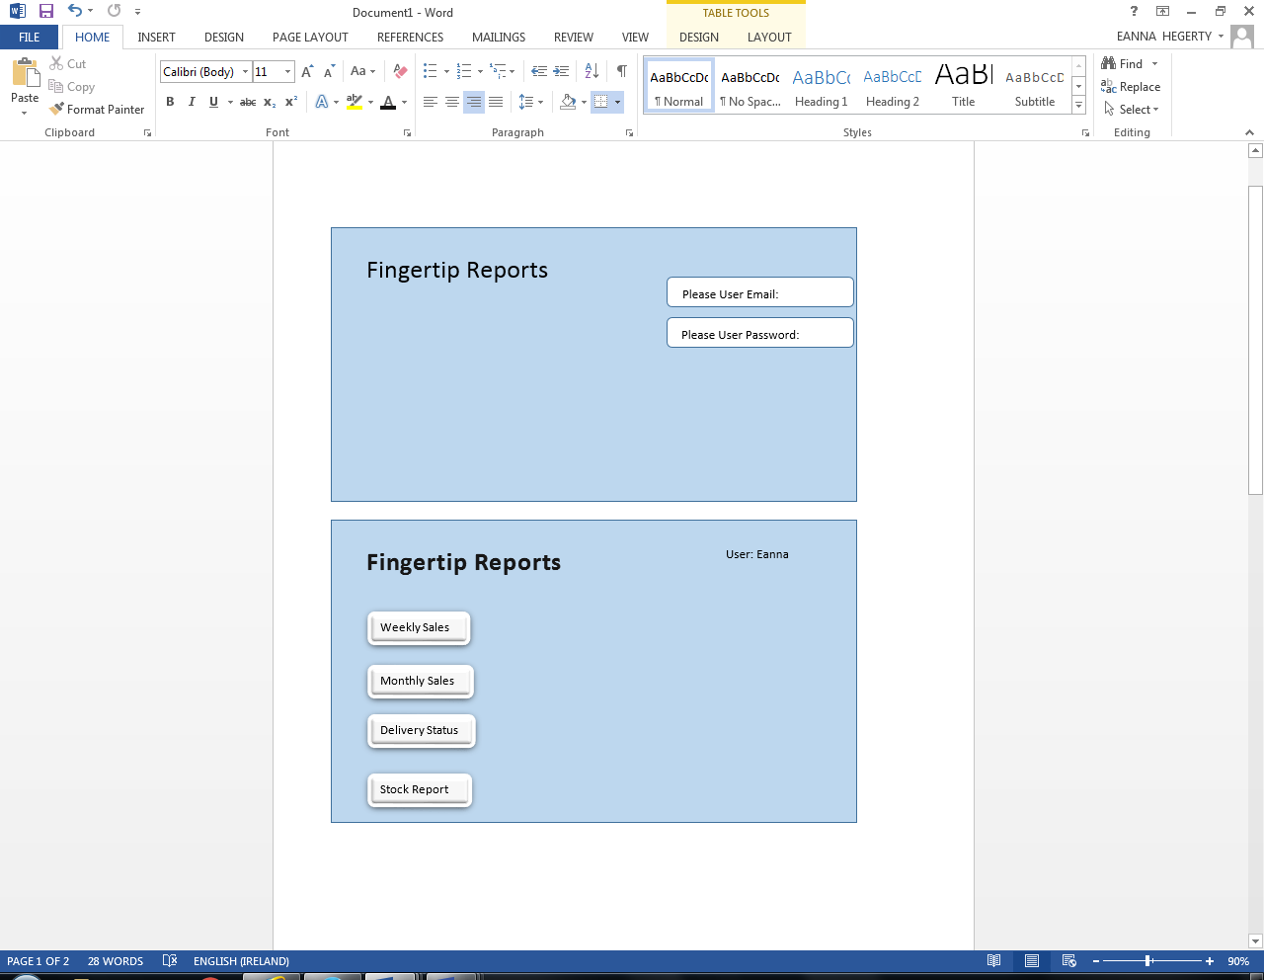

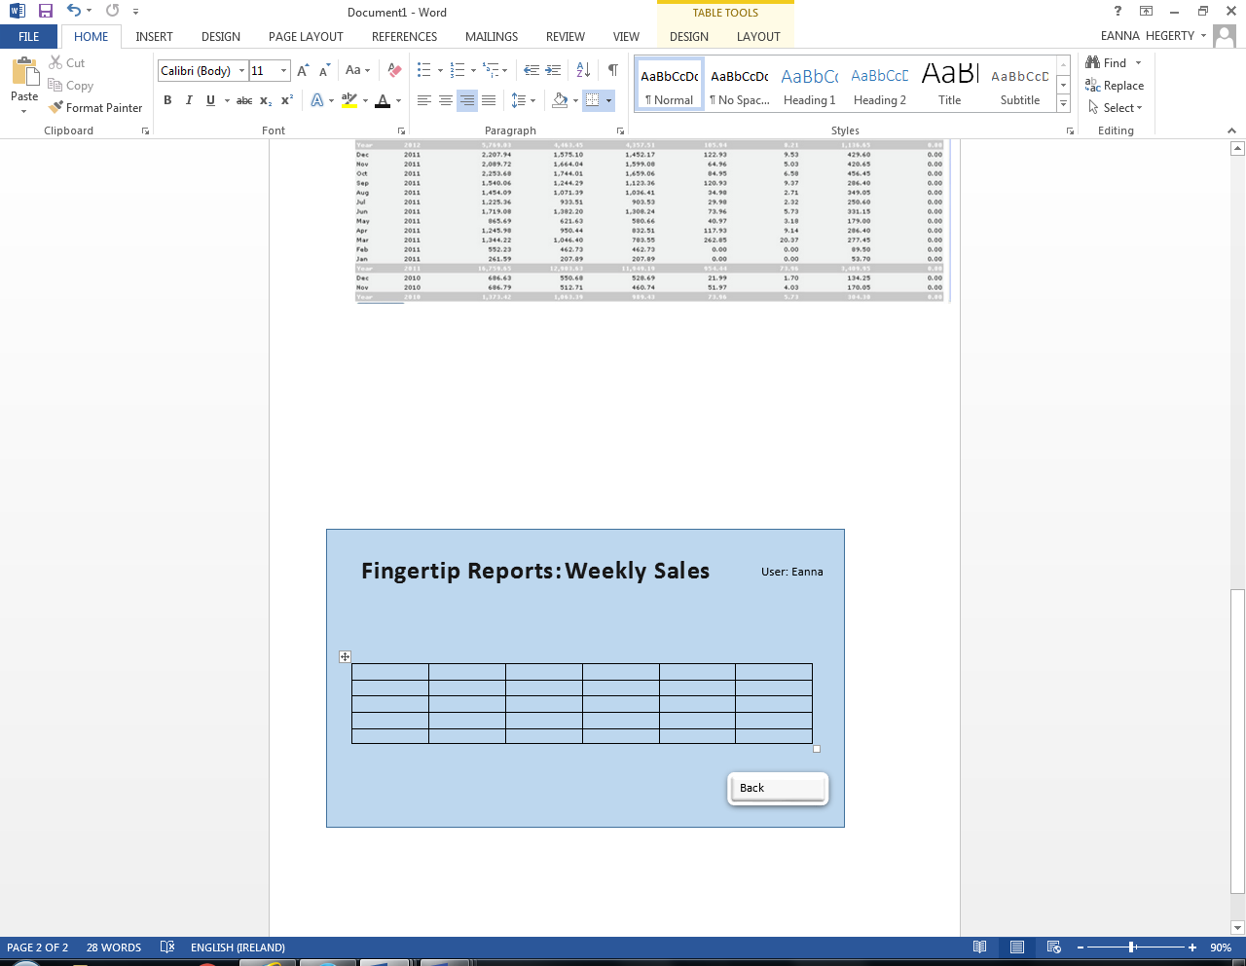

# Iteration 1

As we can see below the first GUI iteration has a very different design to the original prototype design.

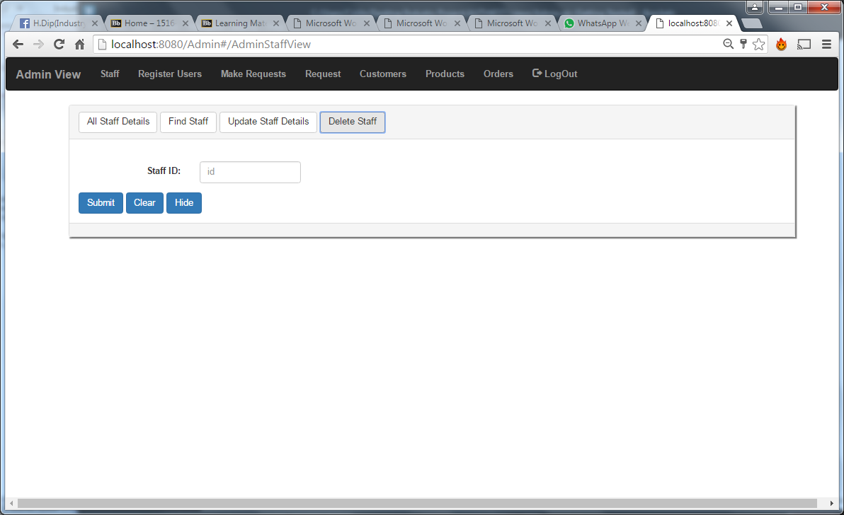

**Black and white colour scheme**

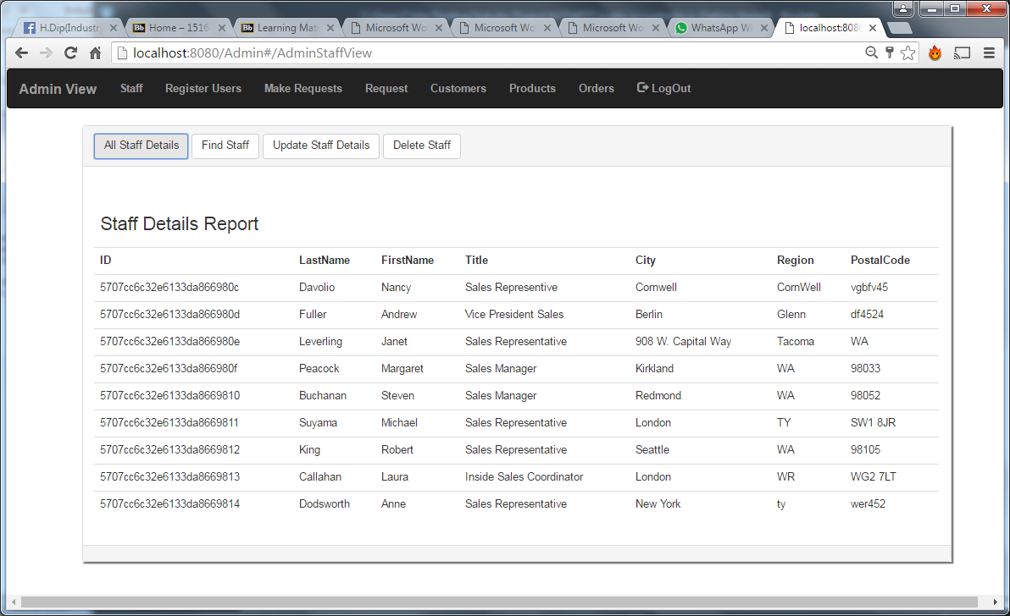

**Menu bar runs across the top of the screen**



**Forms and reports are displayed in a panel with tabs displaying reports optins**



**Button colour is blue instead of grey**



**Tables has no column borders**

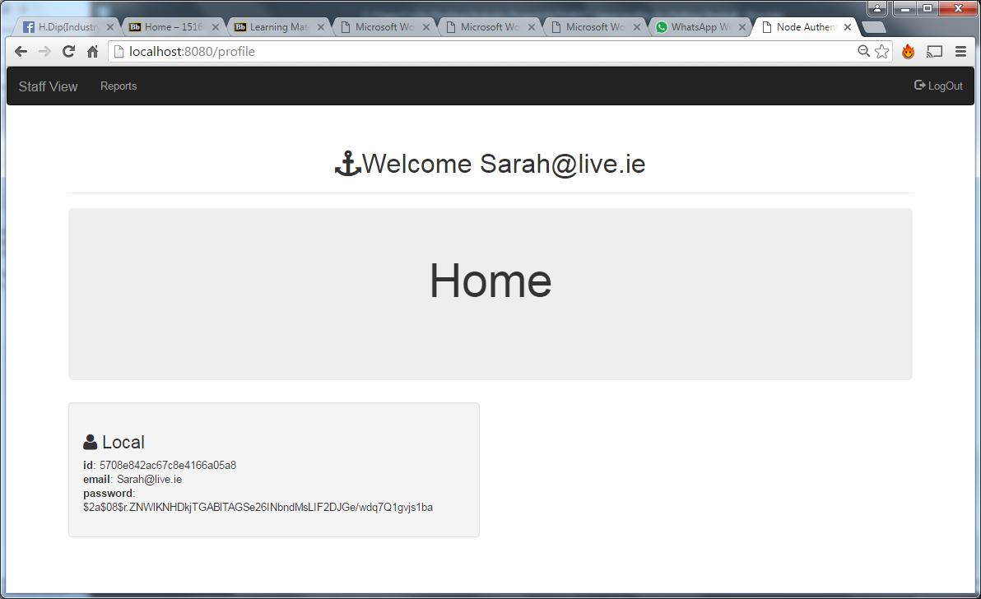

**The profile screen shows just the users email and a link to the reports screen**

# Iteration 3

With iteration of the GUI had several visual changes but also impacted the apis’ with suggestions that the table rows be searchable and editable

.

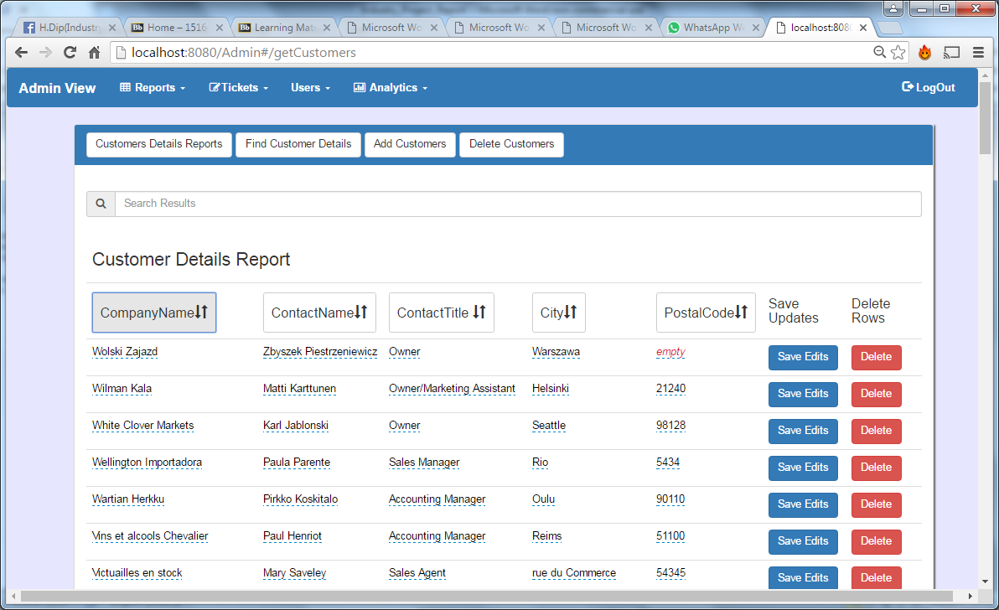

**The colour scheme has change to blue, white and lighter shade of blue.**

# 

**The table headers have been fitted with order by columns and the rows are now editable.**

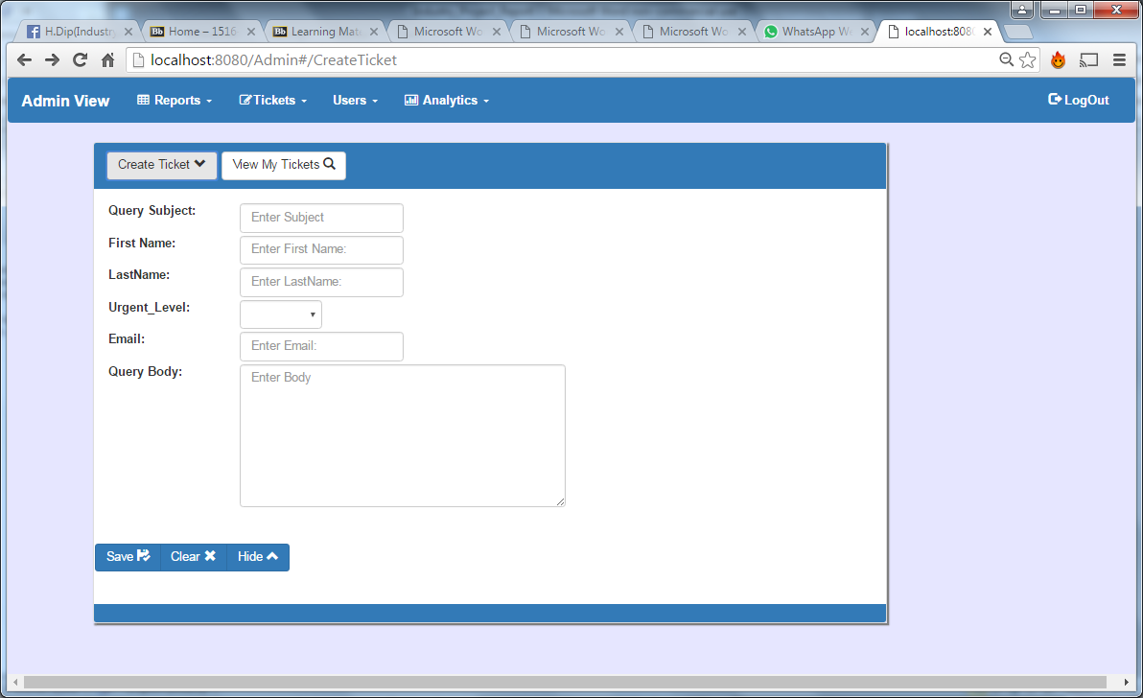

**Glyph icons have been added to all the buttons of the system helping users to navigate and use the application**.



**The Menu bar has become more advanced; the application section have been grouped into new sections and drop-down menus to access the various sub sections.**

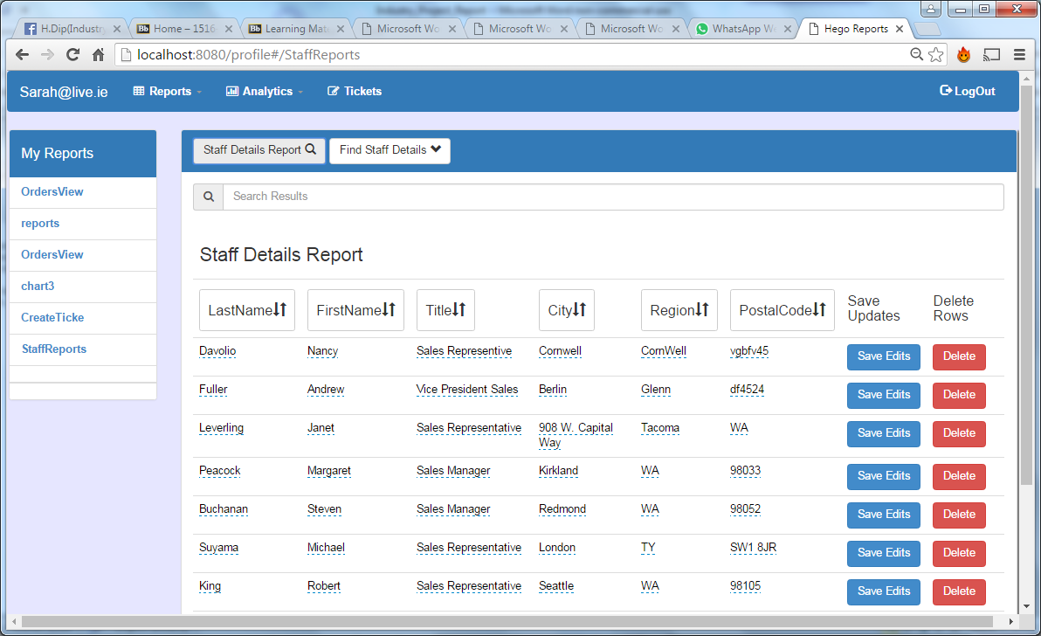

**System no longer split in profile and reports page all user reports are available in their profile page**

With iteration 2 of the GUI there was several changes made to the system as you can see below

* The colour scheme has change to blue, white and lighter shade of blue.
* The Menu bar has become more advanced; the meus are now dropdown and have gathered the different reports together.
* The system was split into 2 section at iteration 2 profile and reports.
* Glyphicon have been added to all the buttons of the system helping users to naviaget and use the application

# Key Functionality & Code Break Down

## Login System & Security

|  |  |
| --- | --- |
| Definition | This application functionality was used to stop access to web application if a user was not logged in. It also provided the ablitiy for users to login with the correct details |
| Technologies used | MongoDB, Passportjs, Express.js, Bootstrap |

#### Code

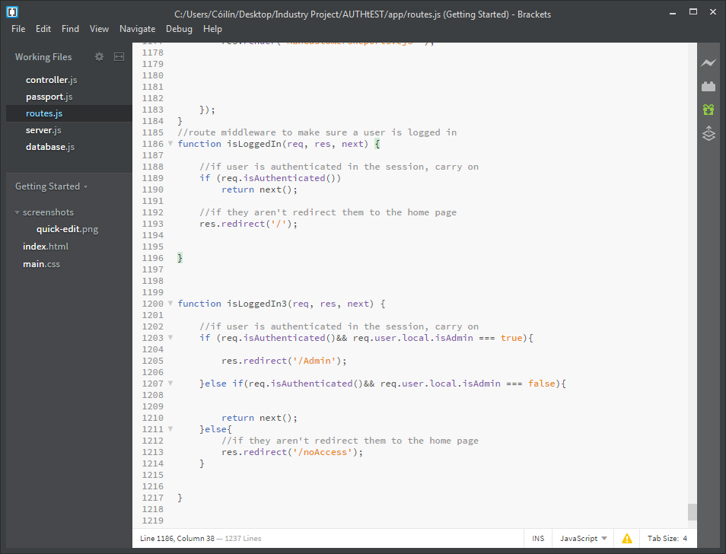

The above code is a middleware function built in express.js, this function checks to see is their a session variable for a client attempting to access a webpage page or an api. If present the function allows users to access the requested url; else the user is redirect index page. This middleware function cis be seen passed int an express listener as an object function as a parameter and is invoked when an event is occurs. For example the below code shows a page request through a get request that is picked up by an express listener, isLoggedIn function is then invoked after which if successful call the requested page will be rendered.

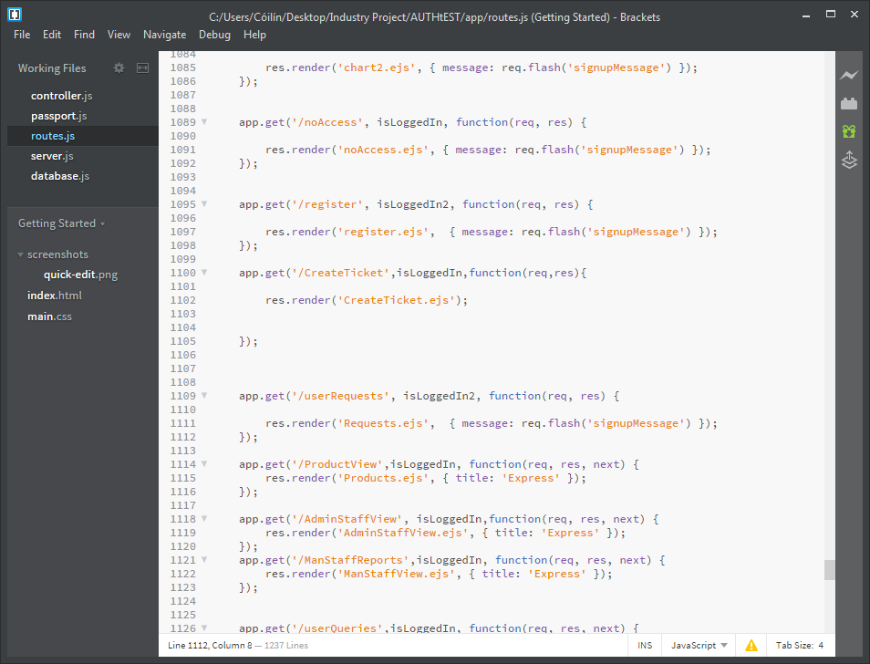

The second piece of functionality that associated with the login and security system is lthe actual loggin in of a user and saving a user session variable.

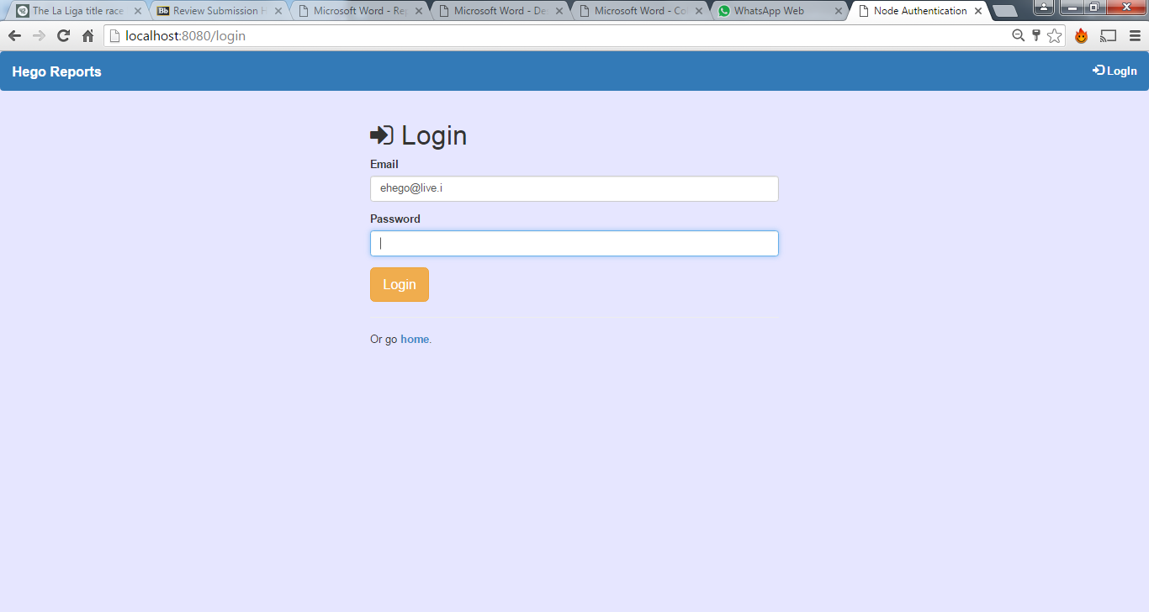

The above login design was done with bootstrap; once the user enters their details an http post request is made which is picked up by express middleware listener for /login url request. At this point passport.authenticate strategy is invoked which is a required module.

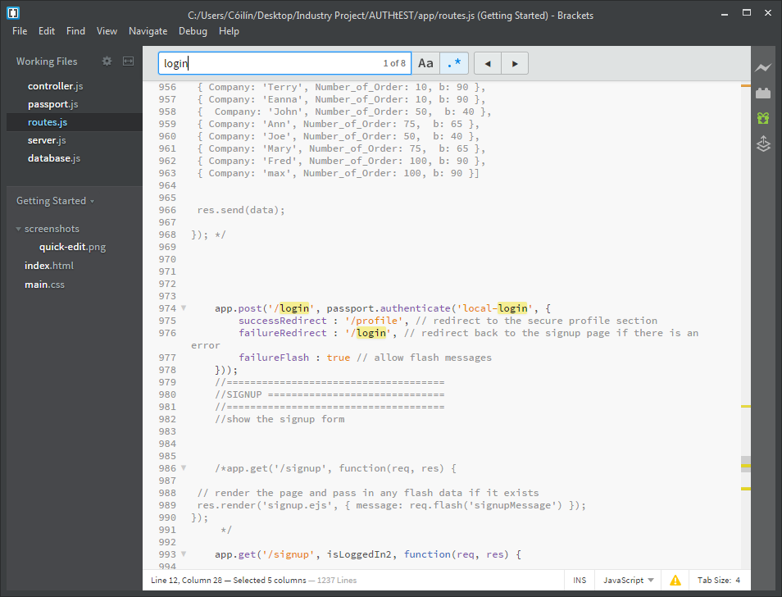

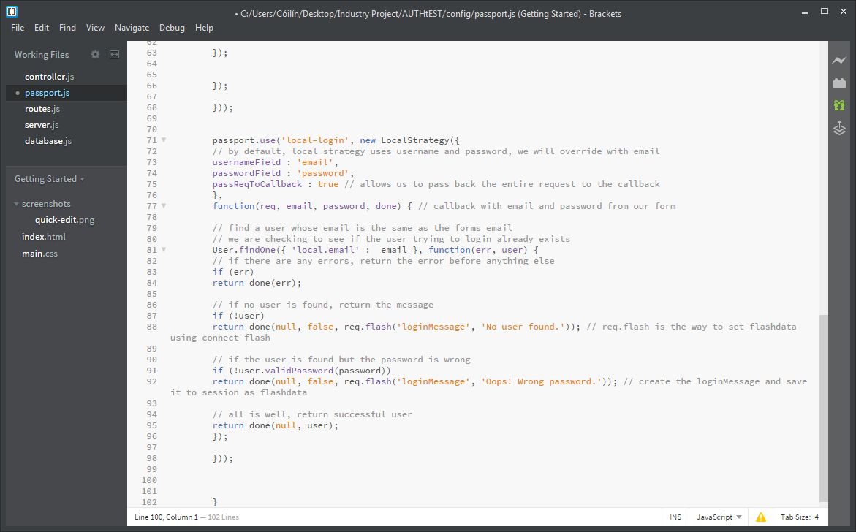

Once passport.authenticate strategy is invoked the email and password from the login attempt are assigned too variables within a new local strategy object. Following this an anonumunise function is invoked that searches the user’s collection within mongoDB via for a matching email, this functionality is provided using the mongoose scheme defined below. If the result is an error return the error, or if email address is not found within the database end the function and inform the end-user. If the email address is found the function now checks to see if the password matches again if not a match, the function ends after informing the user, else it returns the user session variable. At this point the user is logged in and brought to their profile screen.

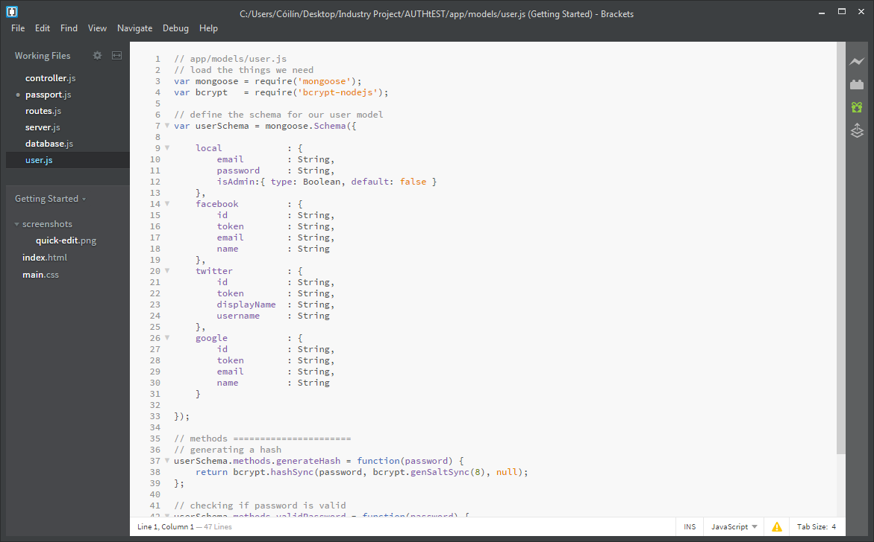

## Create Product Document

|  |  |
| --- | --- |
| Definition | The create document functionality is used to add products the MongoDB through a create api. The user enter product information via a form that then triggers an angular function that makes a http post request which is picked up by an express middleware listener, which creates a new product in the database and then informs the user if the product was created or not. |
| Technologies used | MongoDB, Express.js ,Bootstrap, Angularjs |

# 

The above form takes input from the user, unless the user enters data in all the fields the save button is disabled using the angular directive ng-disable.

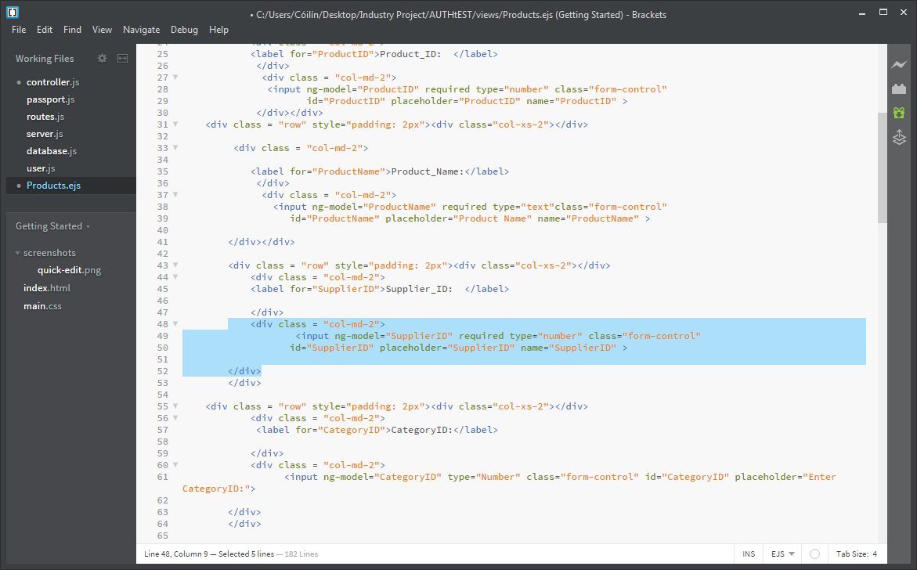

Each user input is stored to an angular variable using the ng-model directory.

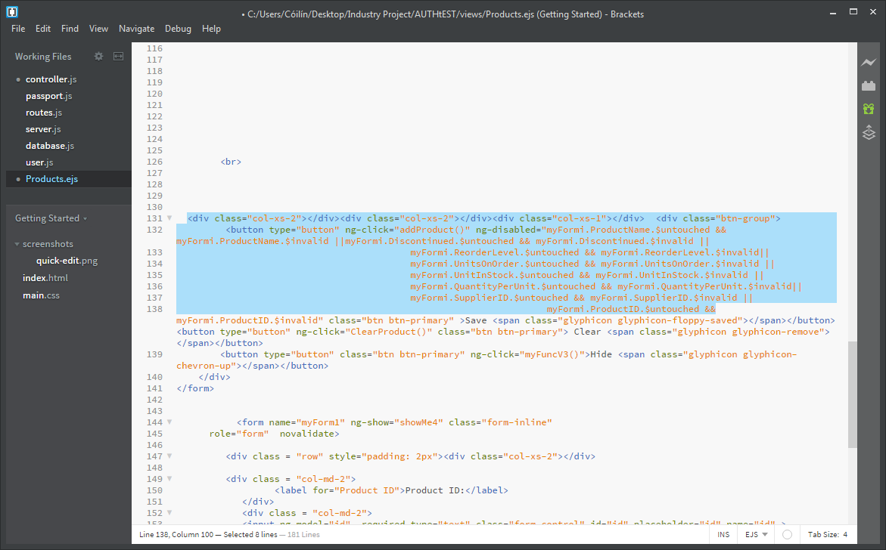

Angular ng-click invokes the addPruduct() function in the views controller.

The addPruduct() function assigns the values entered by the user to a json object.

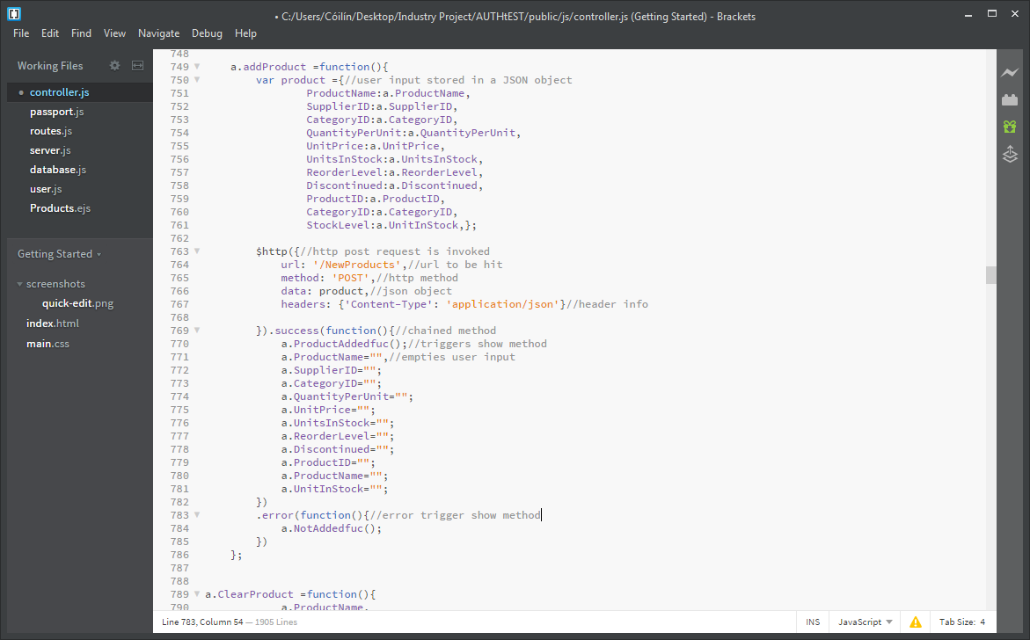

This object is then sent in a post http with other header information.



The function then waits for a response which will be either successful and lead to the user input being cleared and ProductAddedFunction being invoked (Displays a message to user informing them product has been added); or error chain function is called which kicks off NotAddedFunction being invoked and user shown a message informing them product was not added.



Now we can follow the http request to an express.js listener. We can see in the below screen shot that the listener first check to see the user logged in as explained in login section.

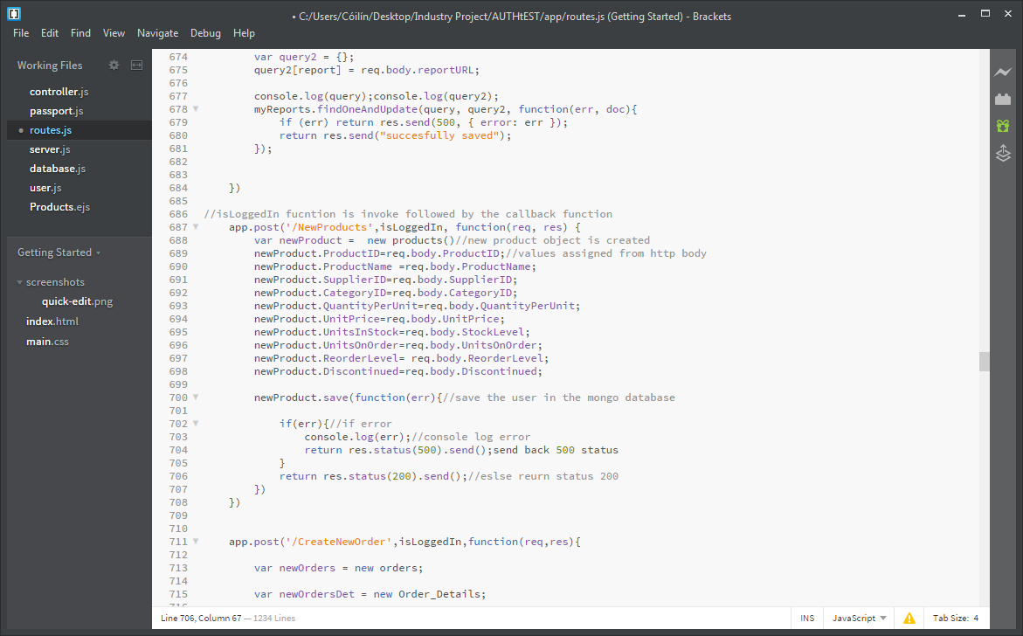

The function then invokes middleware function that assigns the request body values to a new product object the schema of which can be seen below (created using mongoose). Using mongoose the product will be saved to the MongoDB database. If error, status 500 is sent back else a status 200 is sent as the response to the angular function.

# 

## Update Customer

|  |  |
| --- | --- |
| Definition | The update document functionality is used to add products to MongoDB through an update api. The user first click on the field they wish to edit. Once the user has edited the required information and hit saved an angular function that kicks off a put http request which is picked up by an express listener, which updates customer’s details in the database. |
| Technologies used | Mongodb, Express.js ,Bootstrap angularjs |

# 

The user pick a field in which the want to edit, the field then becomes a form in which they can change the current value, the user then click ‘Save Edits’ button containing an angular ng-clicks directive, that invokes an angular function UpdateCustomers which takes in the values of table row as it parameters.

#### Angular code

We can see above the table contents being taken in and assigned to json object.

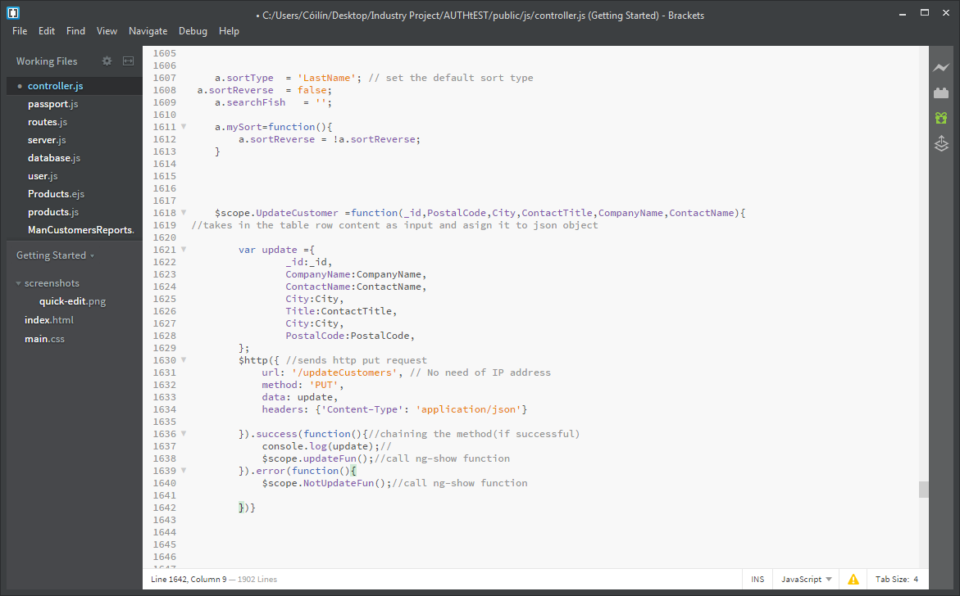

Following this a put http request is sent with the update array being sent in the body requests body.



Chaining is then carried out and if the http response returns successful a ng-show function is invoke that informs the user that the customer has been updated. Else and error function call ng-show that informs the user the customer has not been updated.



#### Express Code

If we follow the request we can see the update customers api we can see that the database is search by the id provided in the body of the request using mongoose object customers. If there is an error while searching the database a status 500 is sent back and function ends.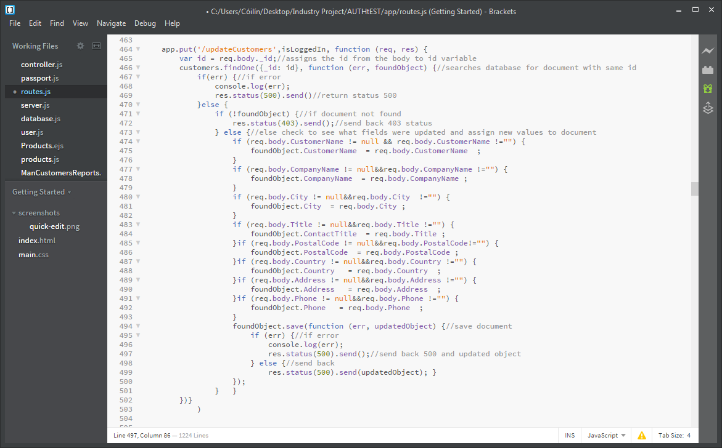

If no document is found status 403 is sent back and function ends. .



If document is found; checks are carried out to see what fields have been updated by the user and assigns these new values to the document. The object is then saved and status 200 is sent back or if an occurs while saving error status 500 to the angular function.



## Delete Customer documents

|  |  |
| --- | --- |
| Definition | The delete document functionality is used to delete customers to MongoDB through a delete api. The user first clicks delete on the delete button of the row of which they wish to delete. An angular function then kicks off a delete http request which is picked up by an express listener, |
| Technologies used | Mongodb, Express.js ,Bootstrap, angularjs |

# 

Once the user click on the delete button of a row a modal appear that asks the user are they sure they wish to delete the customer. If they choose delete an ng-click directive invokes the angular function DeleteCustomer() that takes in the id of the document to be deleted. A second function is also invoked to remove the row from the view removeUser().

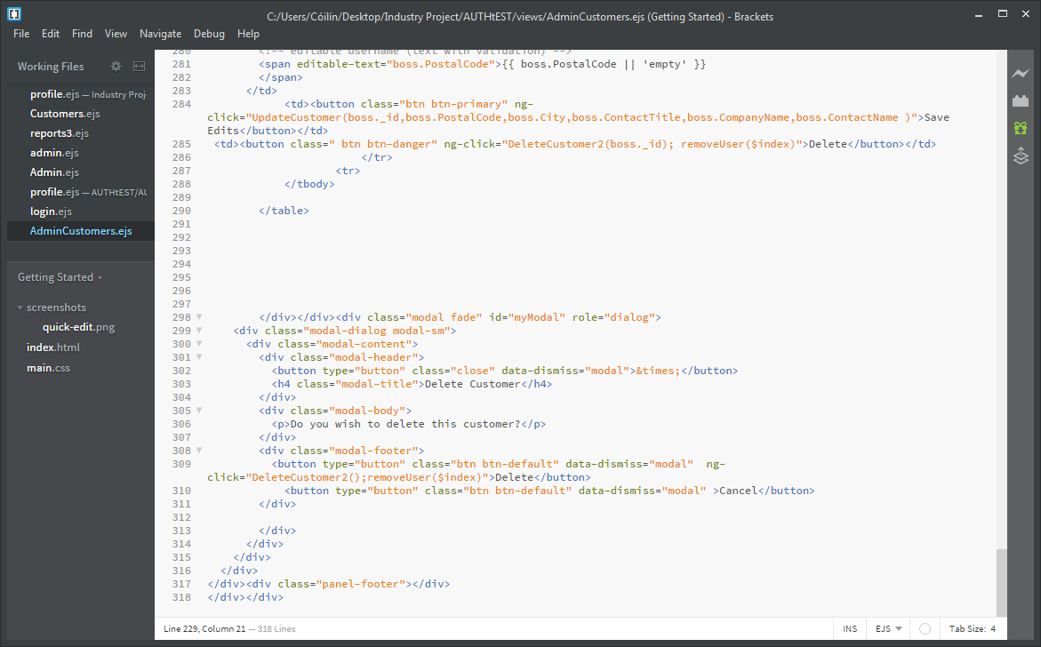

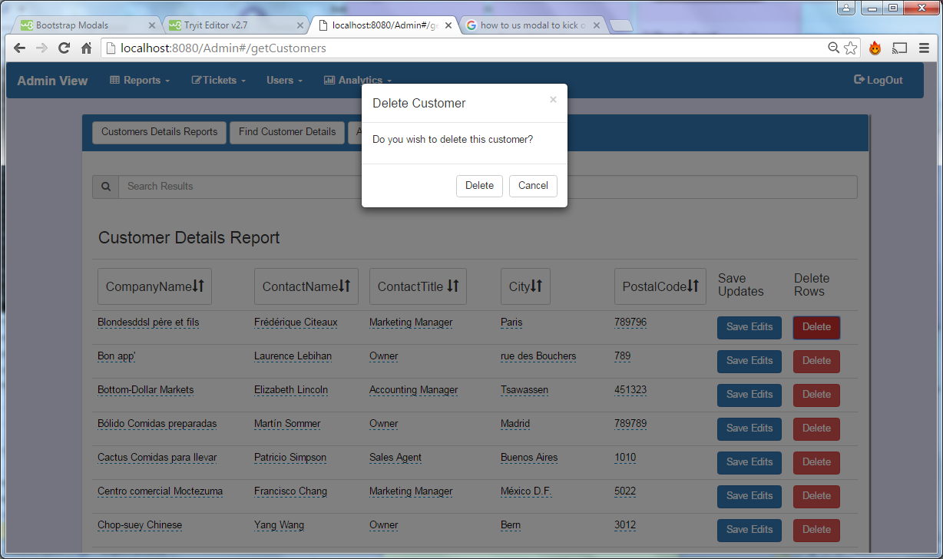

Below is the code belonging to the DeleteCustomer() function, which takes in the document ID and makes a http delete request sending the id through the url. Following this request are chained functions for both success and error responses. If the api response returns successful the ng-show directive for customerDeleteFun() is triggered and the user is informed that a customer has been deleted. If the response send back an error the user is informed that the customer was not deleted via notDeleteFuc().

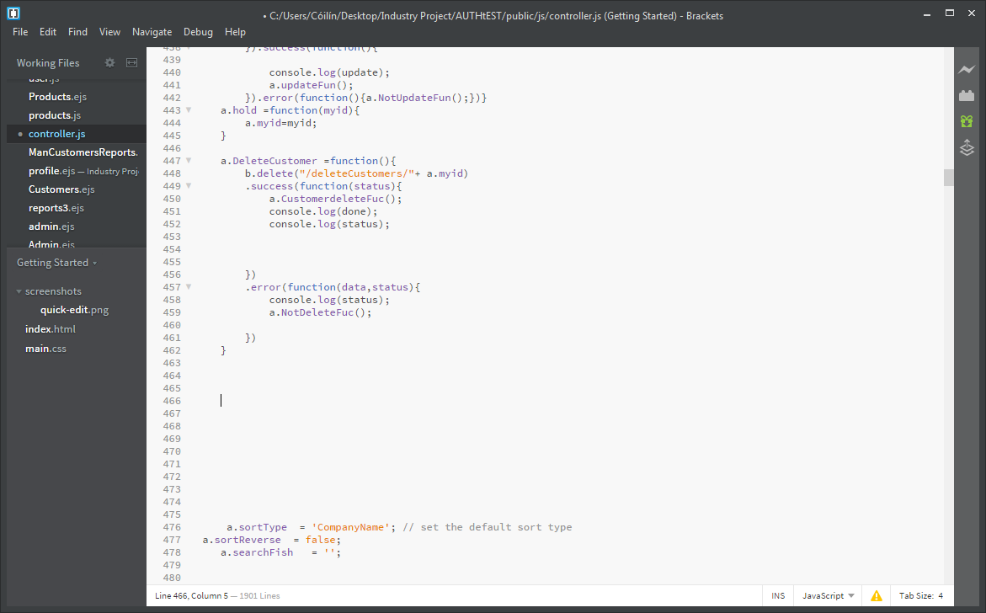

In code snippet code below we can see the id sent during the url request is assigned to a variable which is used to search the MongoDB database for a document with the same id. If an error occurs a status of 500 is return and if the document is not found a status of 404 is sent back. If search returns a document then the database is queried again and removes the document. A successful removal leads to status 200 being returned.

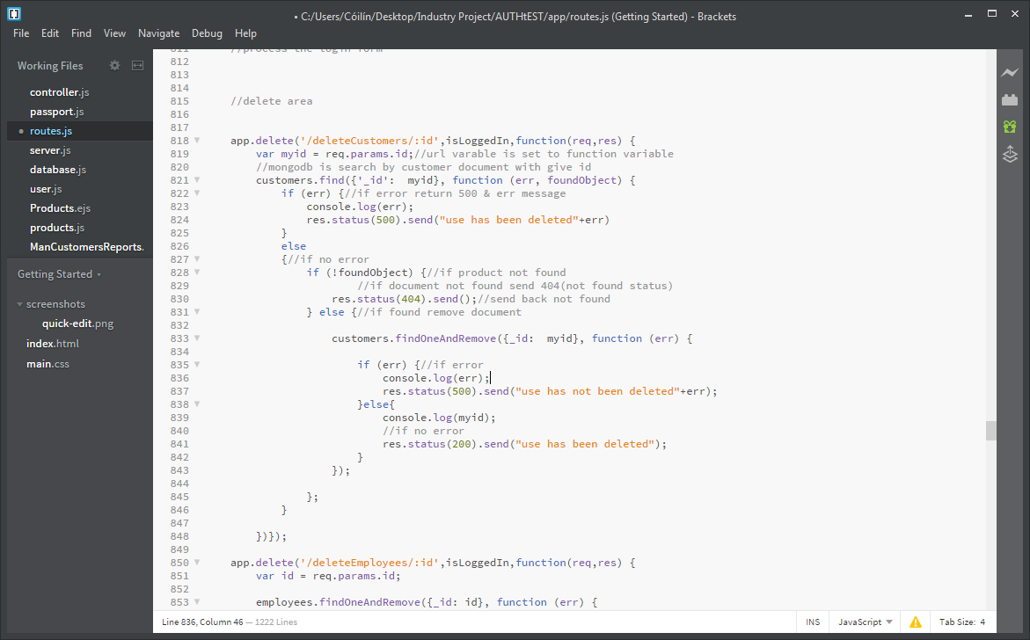

# Testing

## Black Box Testing

**Test Title:** Test api security

**Test Description**

The following test was designed to test the security of end points (api’s). User’s must be logged in to the system to gain access the system api’s data/functionality. To test this process I used postman to hit URL’s with appropriate data while no user was logged in.

**Expected result**

* No api data should be sent back and user should be redirected to login page

**Result Test**

As we can see in the below image not json data was return just the html of the login screen

* Test Passed

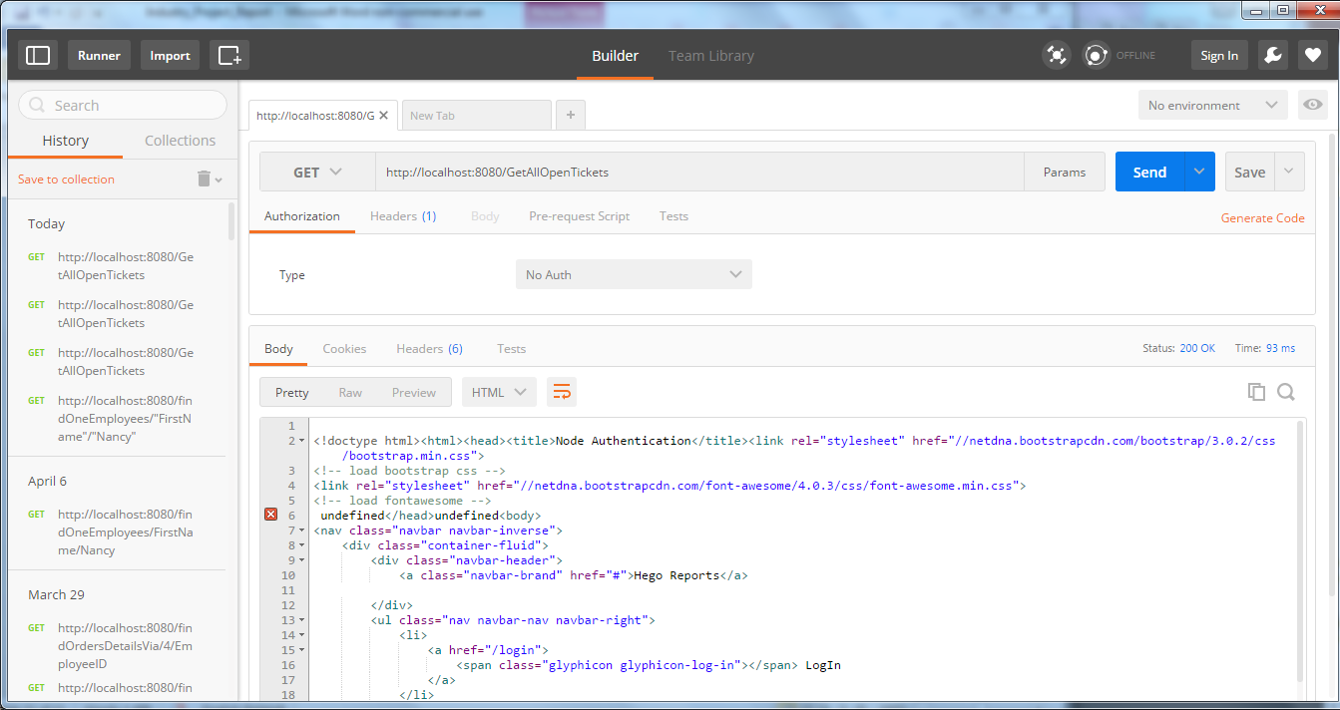

**Test Title:** Test page security

**Test Description**

The following test was designed to test the security of page access. User’s must be logged in to gain access to any webpages. To test this process I used chrome, safari and explore web browsers to try and gain access to given webpages while no logged in.

**Expected result**

* Users should be redirected to index page where they have the option to login

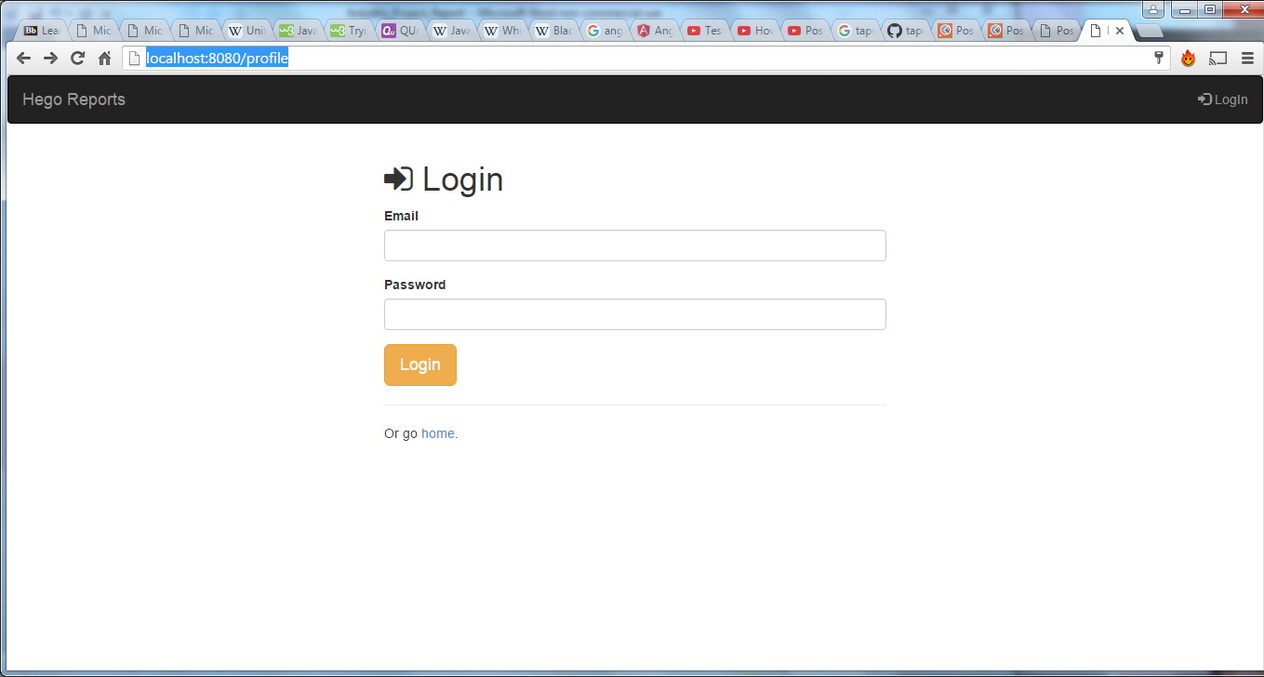

**Test Action**

* No user logged in the following url was hit



**Result Test**

The user did not gain access to their profile page and brought to the index page.

* Test Passed



**Test Title:** Test user admin rights

**Test Description**

The following test was designed to test the administration rights of a given user. A user with manager security rights does not have access to administration pages. The test try’s to get access to a page the user does not have rights to access. To test this process I used chrome, safari and explore web browsers to try.

**Expected result**

* User should be redirected to no access page.

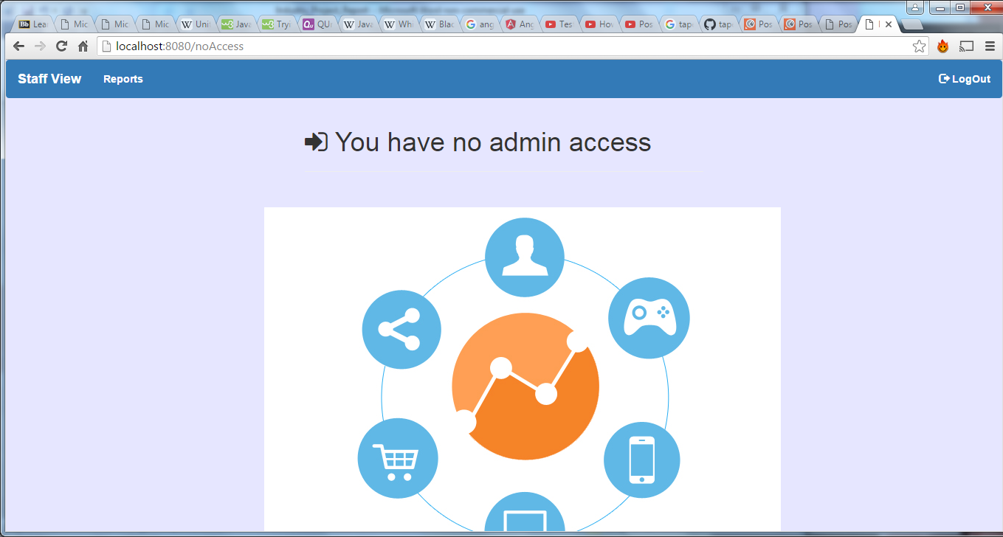

**Test Action**

* User tried to hit /admin route

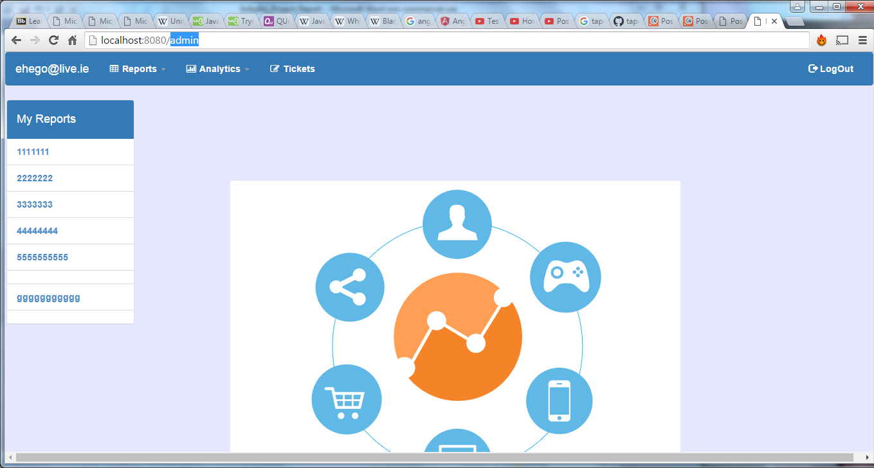

**Test Result:**



The user did not gain access to the administration page and were brought to no access page.

* Test Passed

**Test Title:** Test api’s admin rights

**Test Description**

The following test was designed to test the administration rights of users in regards to api access. A user with manager security rights does not have access to administration api’s. To test this process I used chrome, safari and explore web browsers to try.

**Expected result**

* User should be show the no access page.

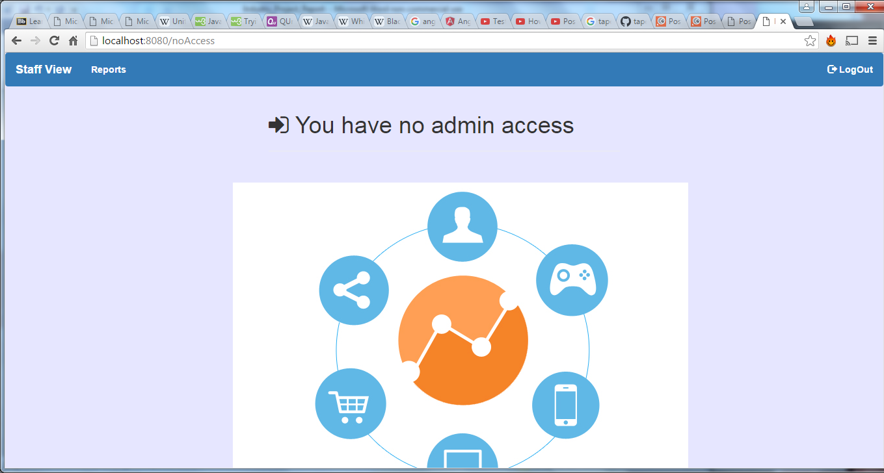

**Test Action**

* User enter is api that they did not have access too.

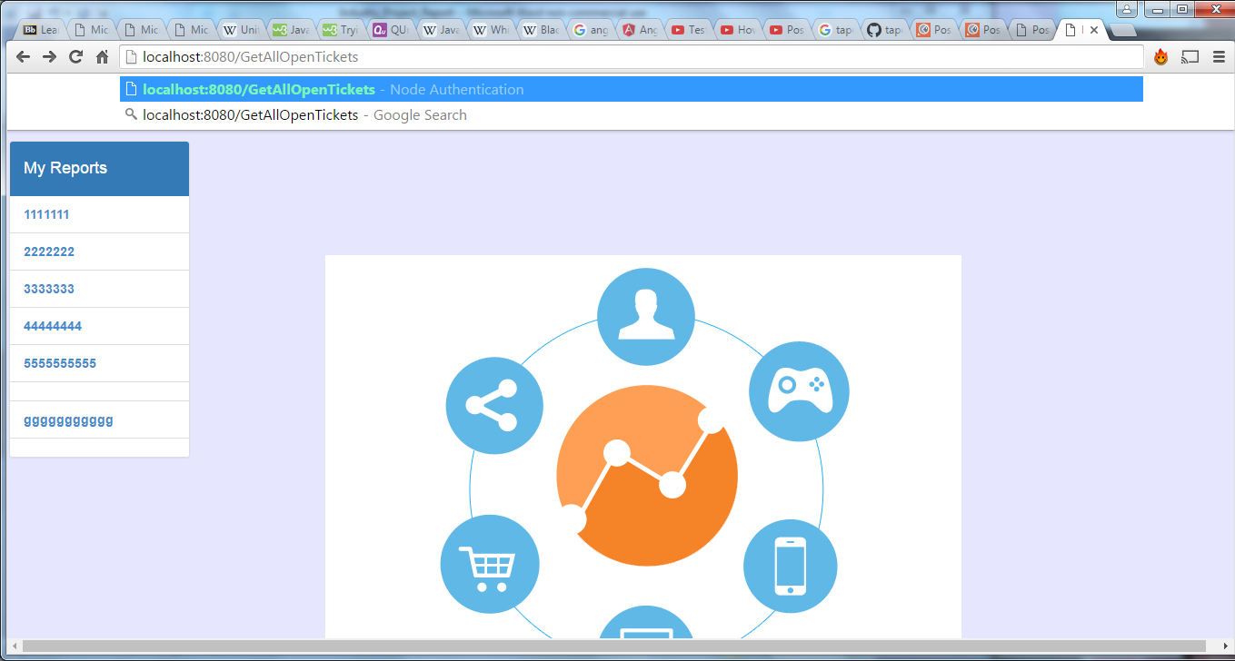

**Test Result**



The user did not gain access to the GetAllOpenTickets api’s and were kicked back to no access page.

* Test Passed

**Test Title:** Test login functionality

**Test Description**

The following test was designed to test the login functionality of this application.

The first part of this test is to assure that a user does not gain access to the web application when they enter the incorrect login details for their account (email or password). The second part of the test is to assure that the user get redirected to their personnel profile screen, with their personnel reports setting. To test this process I used chrome, safari and explore web browsers to ensure that the test worked on several browsers.

**Expected results**

* Test 1: The user should be shown messages informing them they enter wrong email.

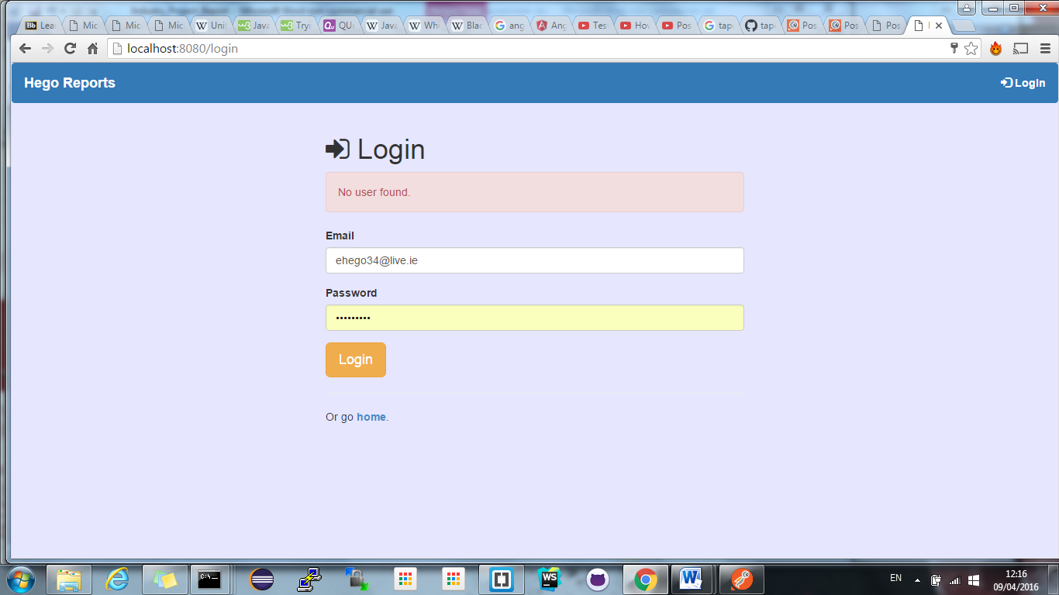

* Test 2: User should be shown messages informing them they enter wrong password.

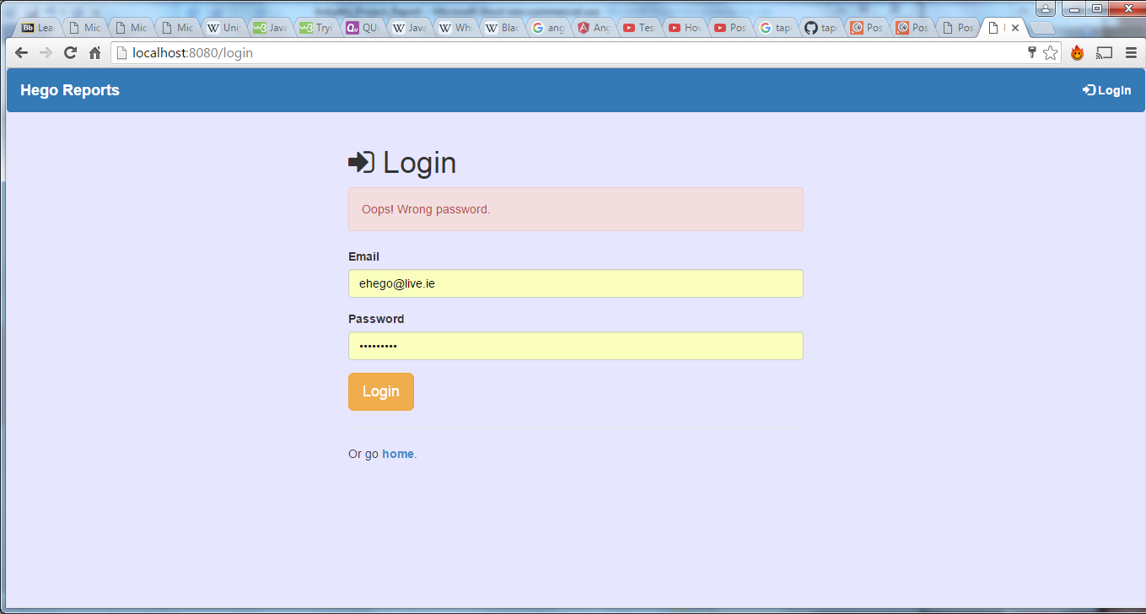

* Test 3: The user should be brought to their profile screen displaying their email address and there personnel reports.

Test 1 action: User enter wrong email address

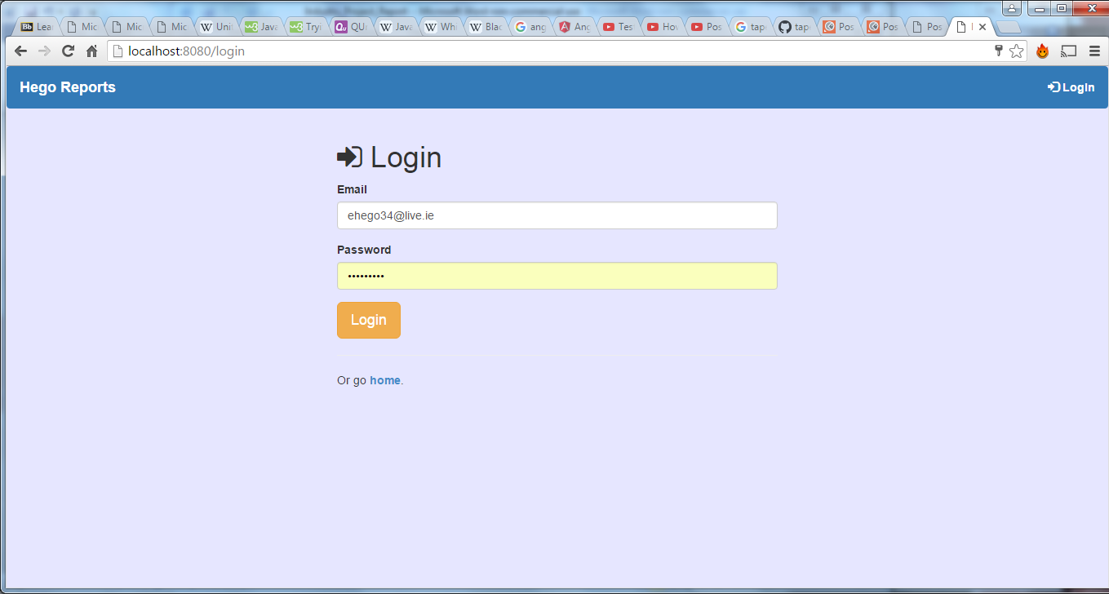

**Test 1 Result**:



**Test 1:** Passed

**Test 2 action:** User enter wrong password

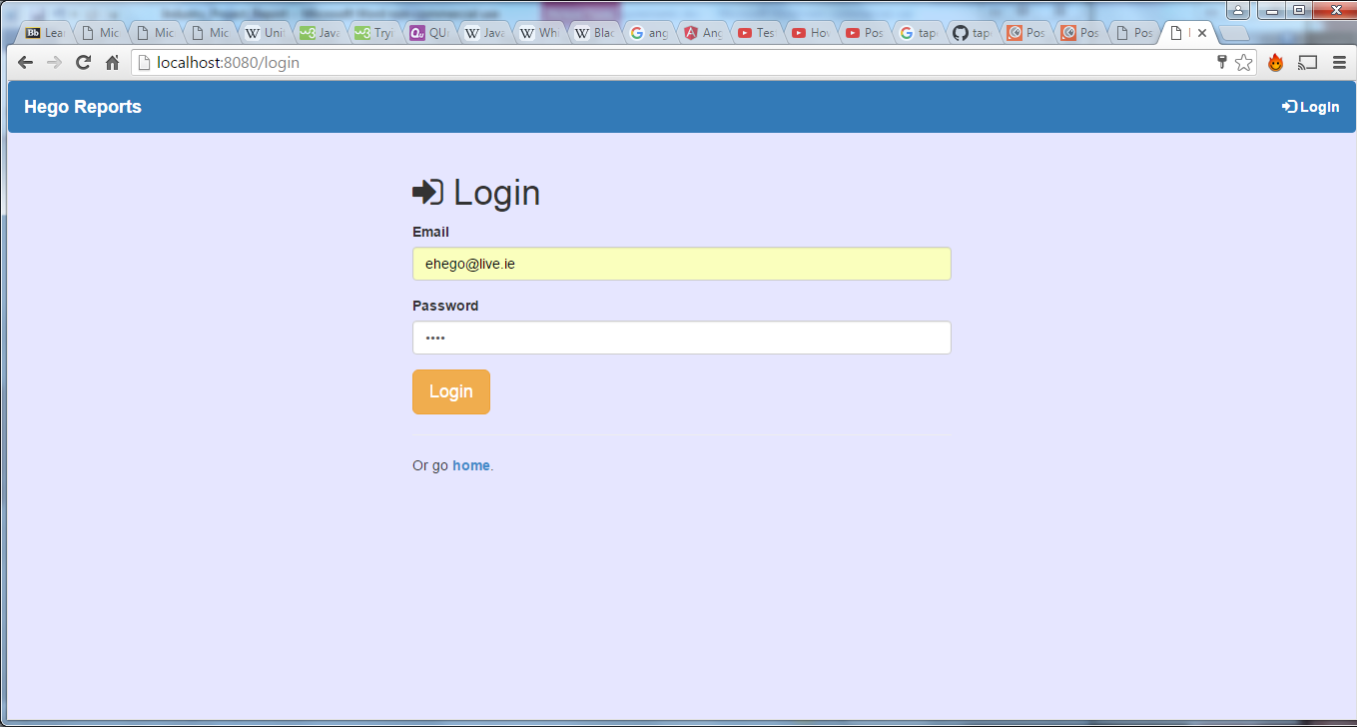

**Test 2: Result**



**Test 2:** passed

**Test 3: action:** User enters correct details

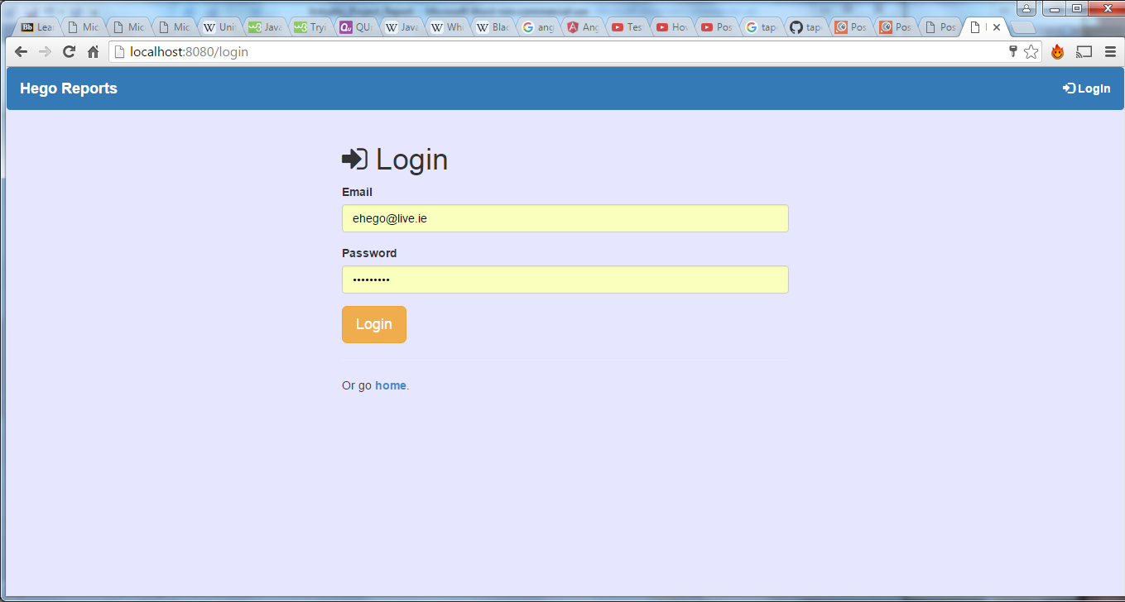

Add screen shot

**Test Description**

The following test was designed to test the register functionality of the system. The first part of this test is to try and register a new user with an email and password. The second part of the test is to assure that the user can log in. To test this process I used chrome, safari and explore web browsers to try.

Expected results

* Test 1: Message showing user has been registered should be shown & database should include new users.
* Test 2: The user should be able to log in with their details and get brought to their profile page displaying their details.

**Test 1 Action**: Register new user details

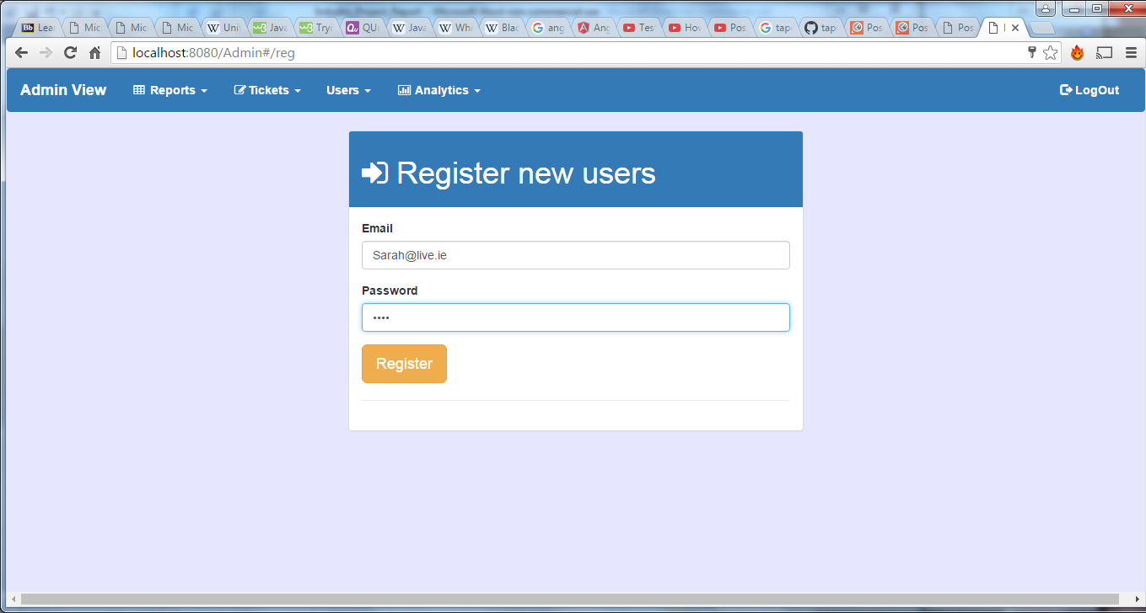

Test 1 Results

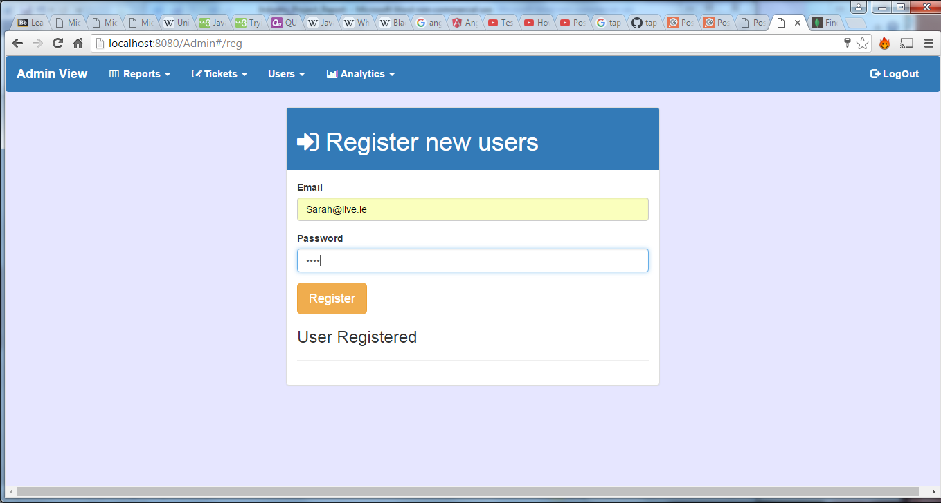

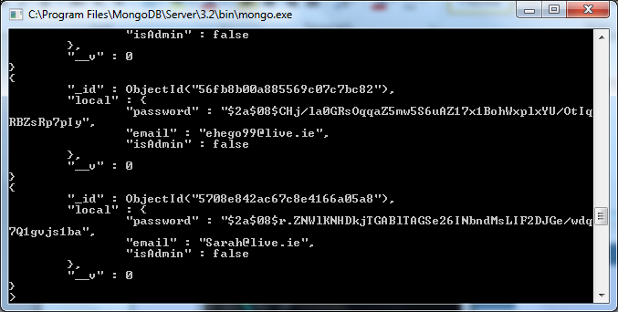

**Test 1:** passed

**Test2:** Action: Login as with user details

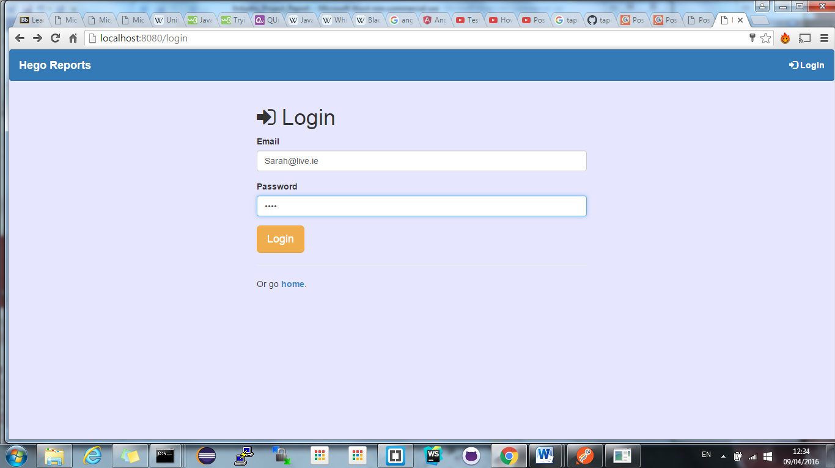

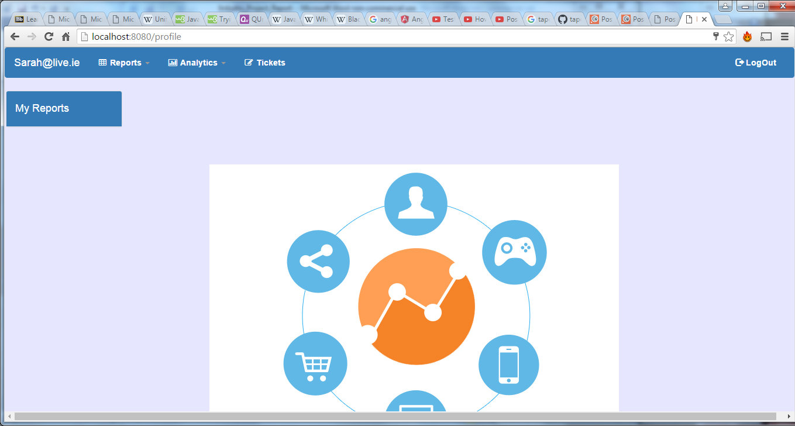

Result: [Sarah@live.ie](mailto:Sarah@live.ie) displayed on profile screen, user logged into newly created account.

**Test 2:** Passed

**Test Title:** Test User profile reports generator

**Test Description**

The following test was designed to test the assignment of personnel reports to users (each user has personalized reports on their profile screen). The personnel reports will are registered to a user via their email address on the admin profile reports page. Once the reports have been registered user should be able to access these reports on their profile page. To test this process I used chrome, safari and explore web browsers to ensure that the test worked on several browsers.

**Expected results**

* Test 1: The user should be shown messages informing them they registered a reports & an entry in the database should show the reports assigned to the users email.
* Test 2: The users should be able to access reports from side menu on their profile page.

**Test 1 action:** register reports to users email address

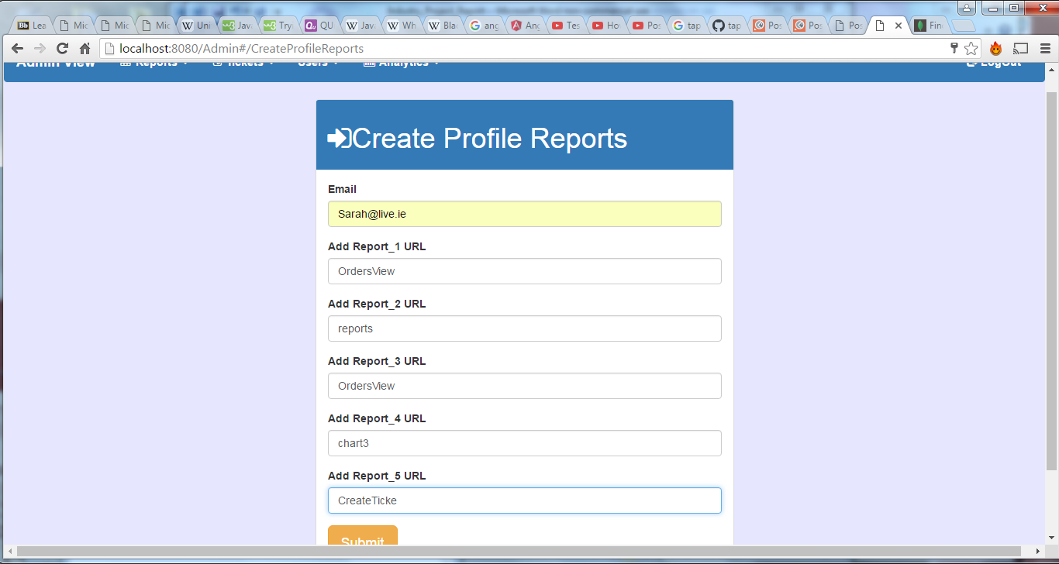

**Test 1 results**: Message has been shown

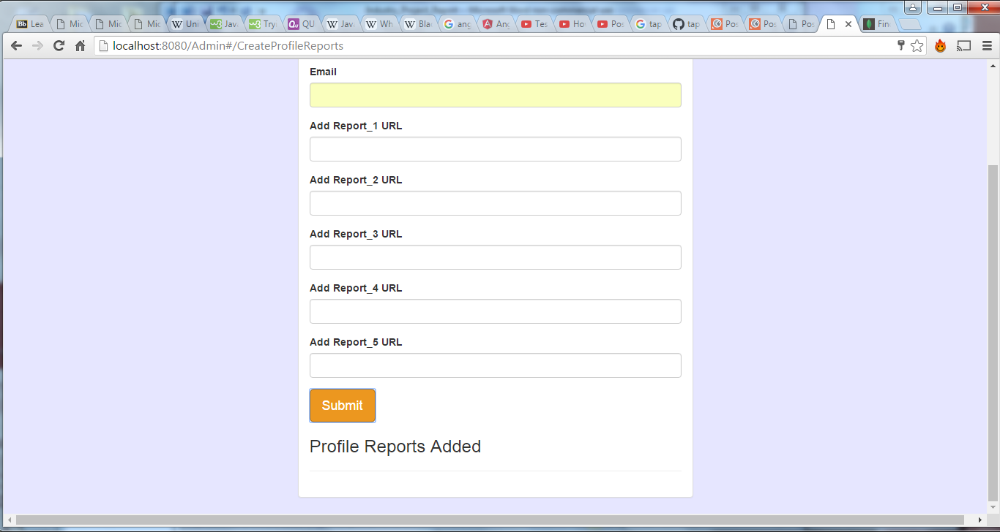

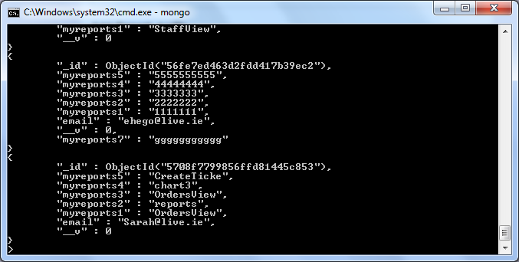

**Test 1:** Passed

**Test 2 action:** Log into profile screen

**Test 2:** result: User has now access to personnel reports

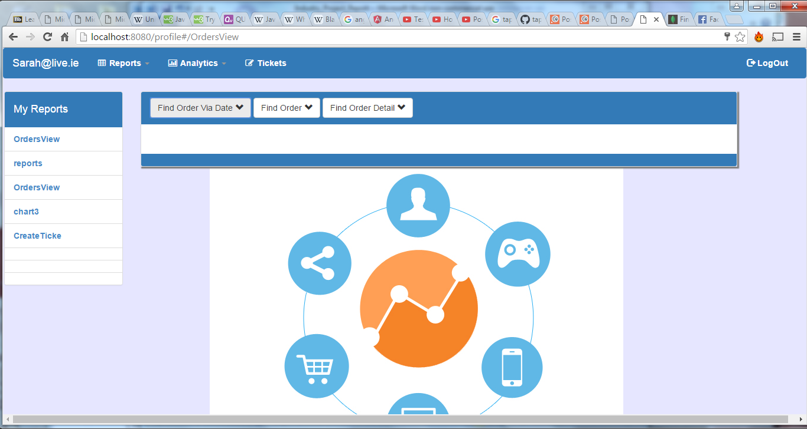

**Test 2:** Passed

**Test Title:** Test Application device independence

**Test Description**

The following test was designed to assure that the application could be used on a wide range of devices, from desktop, tablets and mobile. To test this process I used chrome, safari and explore web browsers to ensure that the test worked on several browsers. The test was done using several mobile devices along with the different device views offered by chrome inspect tool.

**Expected results**

* Test 1: The applications navigation bar should resize on smaller screen 760;
* Test 2: Reports table should become scrollable on screen smaller that 760;
* Test 3: The users should be able chart analytics on any screen size.

**Test 1, 2 & 3 action:** Resized the browser window past 760 in width.

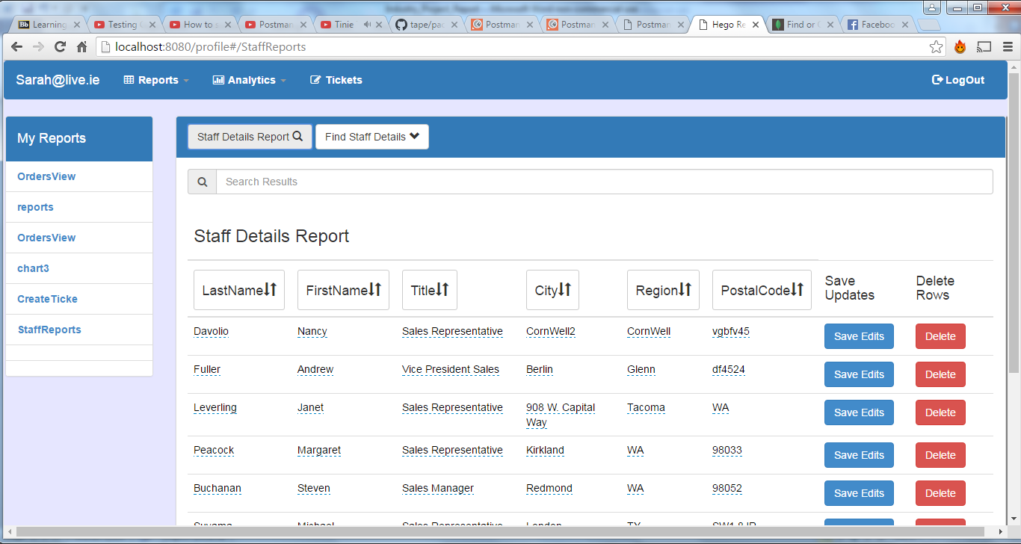

**Test 1 result**: Navigation bar resize as expected

**Test 1:** passed

**Test 2 results**: Table resize as expected with scroll bar

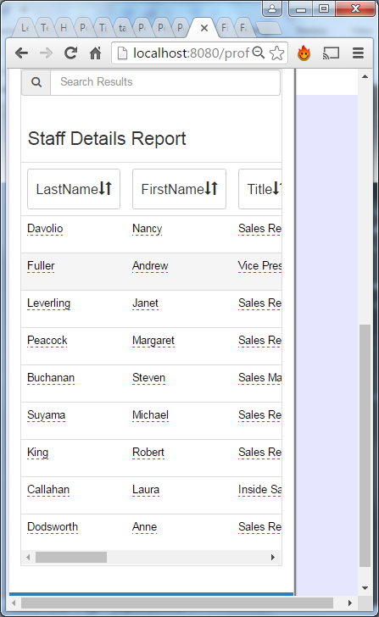

**Test 2:** passed

**Test 3 results**: Table resize as expected with scroll bar

**Test 3:** passed

**Test Title:** Table searching

**Test Description**

The following test was designed to assure that the application could search table results retuned from an api request and only show matching rows. To test this process I used chrome, safari and explore web browsers to ensure that the test worked on several browsers.

**Expected results**

* **Test 1:** The rows displayed only show rows with string that matches user entry.

**Test 1 action:** Entered in string ‘Nancy’ into search bar

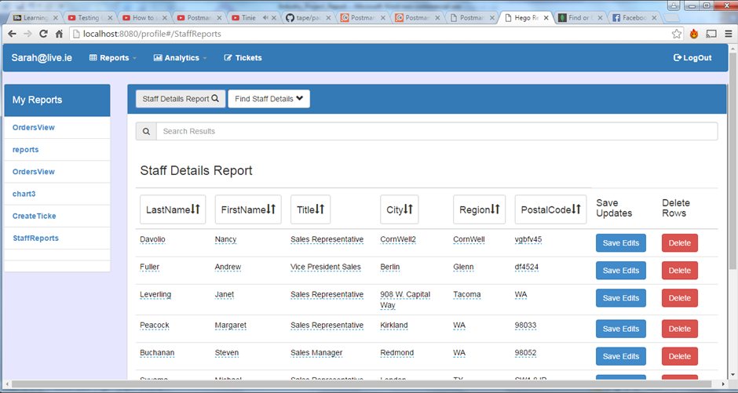

**Test 1 results**: Table return only rows with string ‘Nancy’

**Test 1:** passed

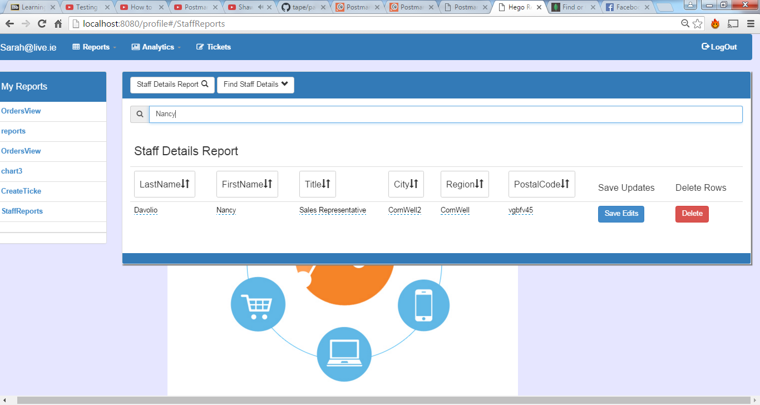

White box testing

**Test Title:** Test to get http request on api

**Test Description**

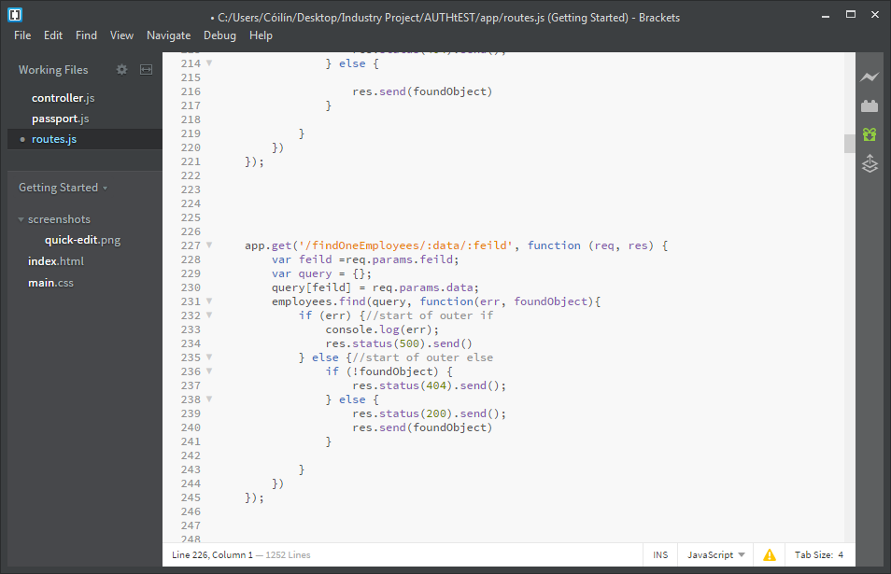

This test was created to assure that the correct json data are returned from the api. Users are able to search for employees by first name, last name or city. As we can see below in postman four test are created:

* **Test 1**: Was to ensure that when the api was sent first name as the query field and correct data that it passed the below tests. Test if correct status, document data(first & last name) and the correct object returned(_id).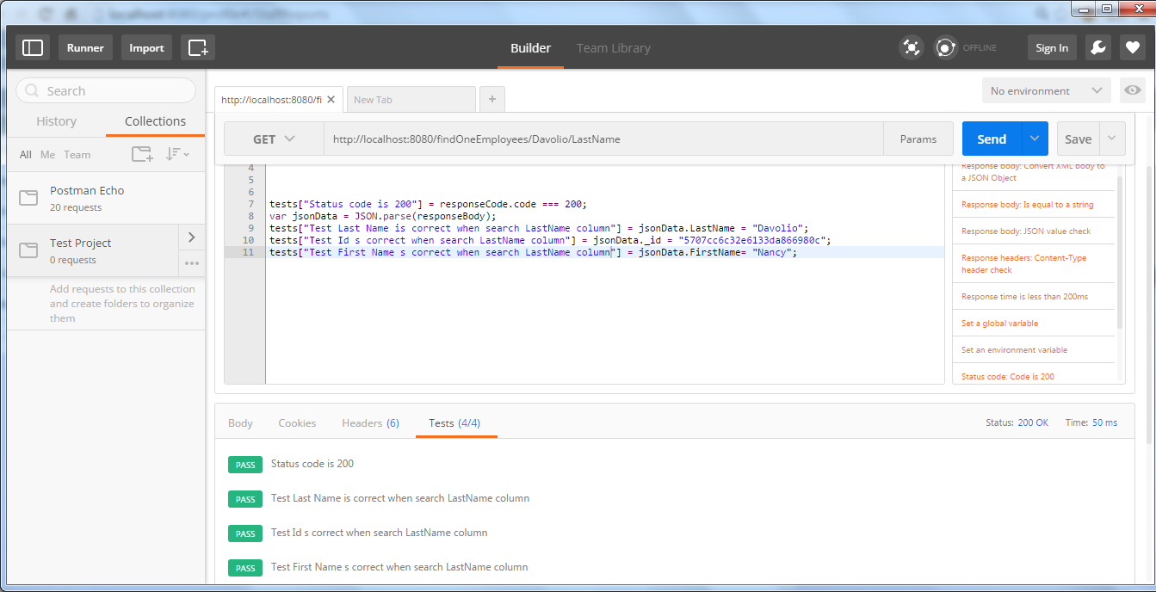
* **Test 2**: Was to ensure that when the api was sent last name field query and correct data that it passed the below tests. Test if correct status, document data(first & last name) and the correct object returned(_id).

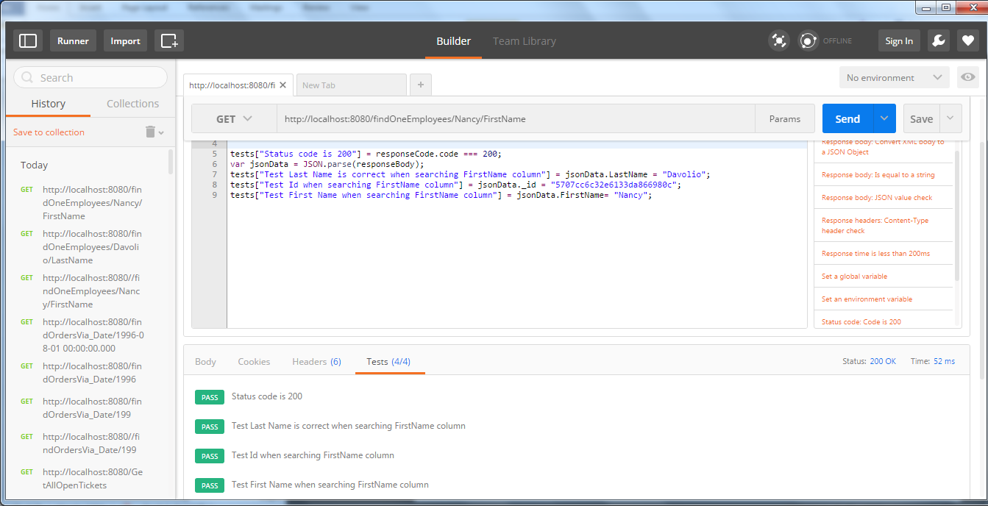

* **Test 3**: Was to ensure that when the api was sent city field query and correct data that it passed the below tests. Test if correct status,document data(first & last name) and the correct object returned(_id). 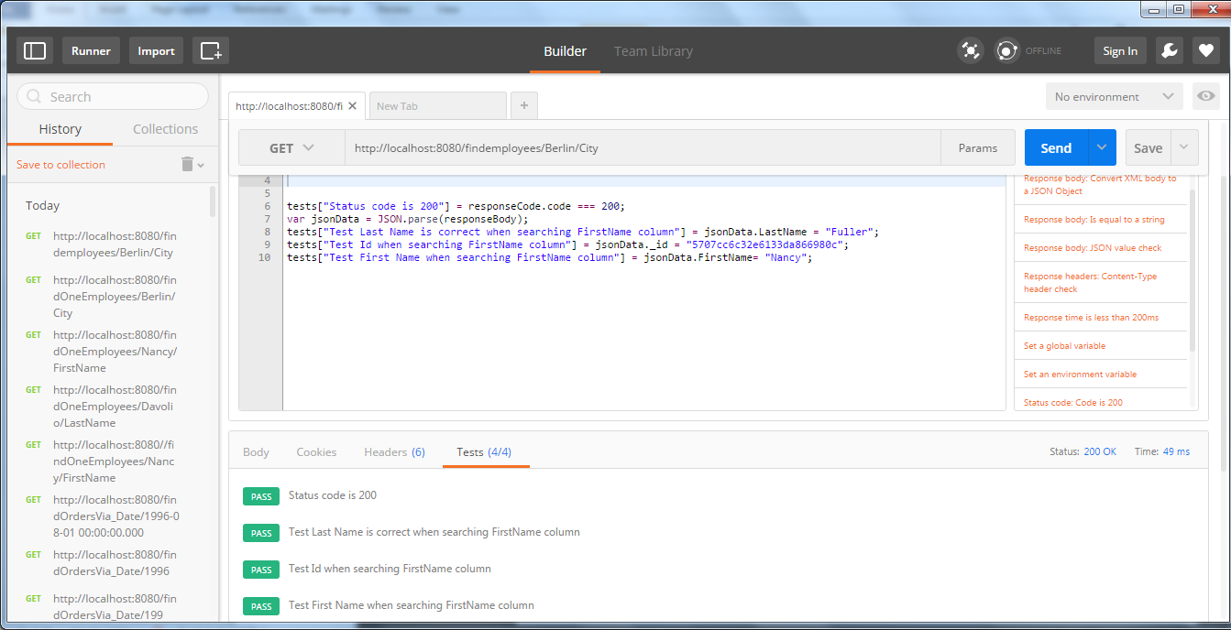
* **Test 4**: Was to ensure that when the api was sent wrong data and that the api would send back status 404.
* 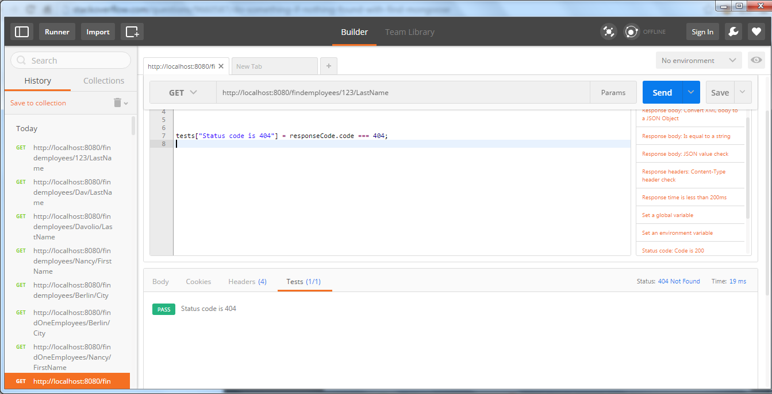

**Test Result:** All four tests were passed and the correct json object was returned.

Test 1:**Result**



Test 2:**Result**



Test 3:**Result**



Test 4:**Result**



**Test Title:** Test to put http request on api

**Test Description**

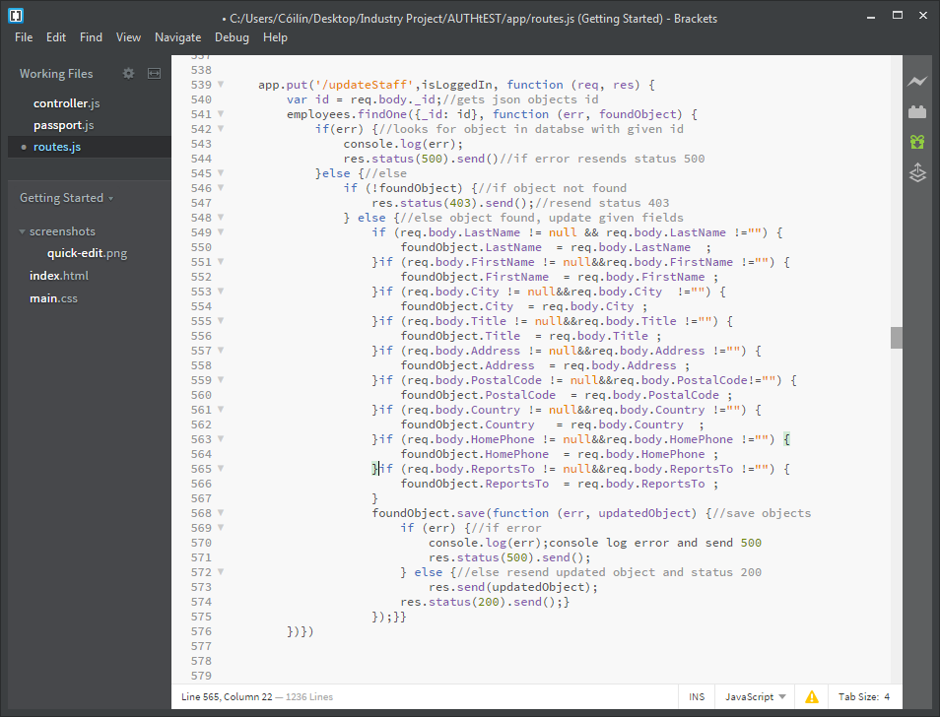

This tests were created to assure that the correct response was returned from my get api when different information was sent to the above api.

**Test 1**: Was to ensure status 404 was sent when user was sent no information in the body of the put request. (No to search up the database)

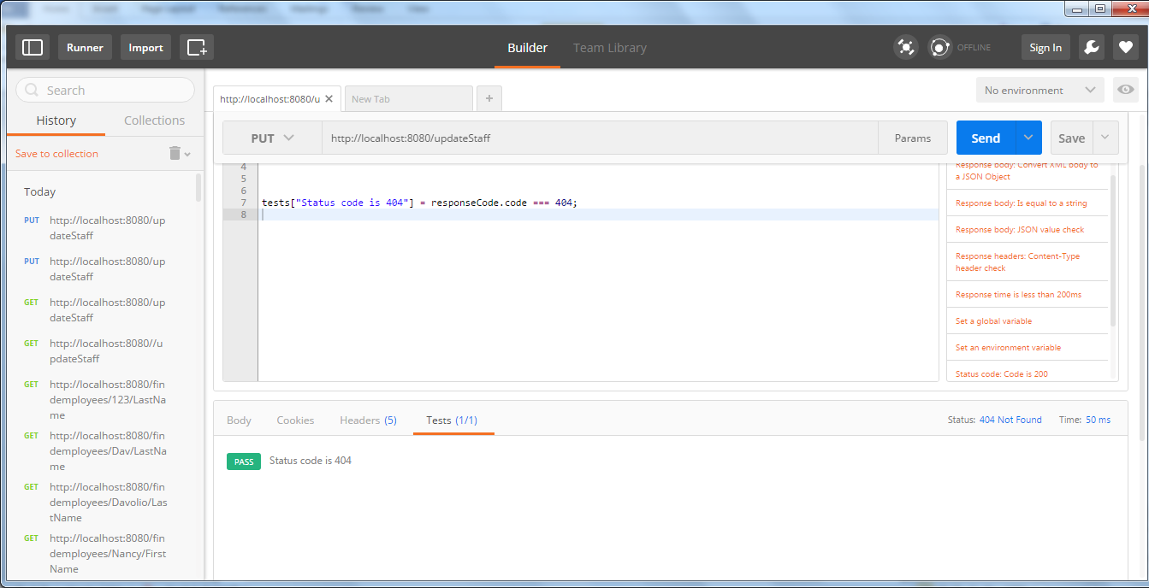

**Test 2**: Was to ensure status 200 was sent when user was sent correct information in the body and that the document was updated. This was done by sending back the updated document in the body of the response and testing was the update filed changed (change Title to Sales Manager).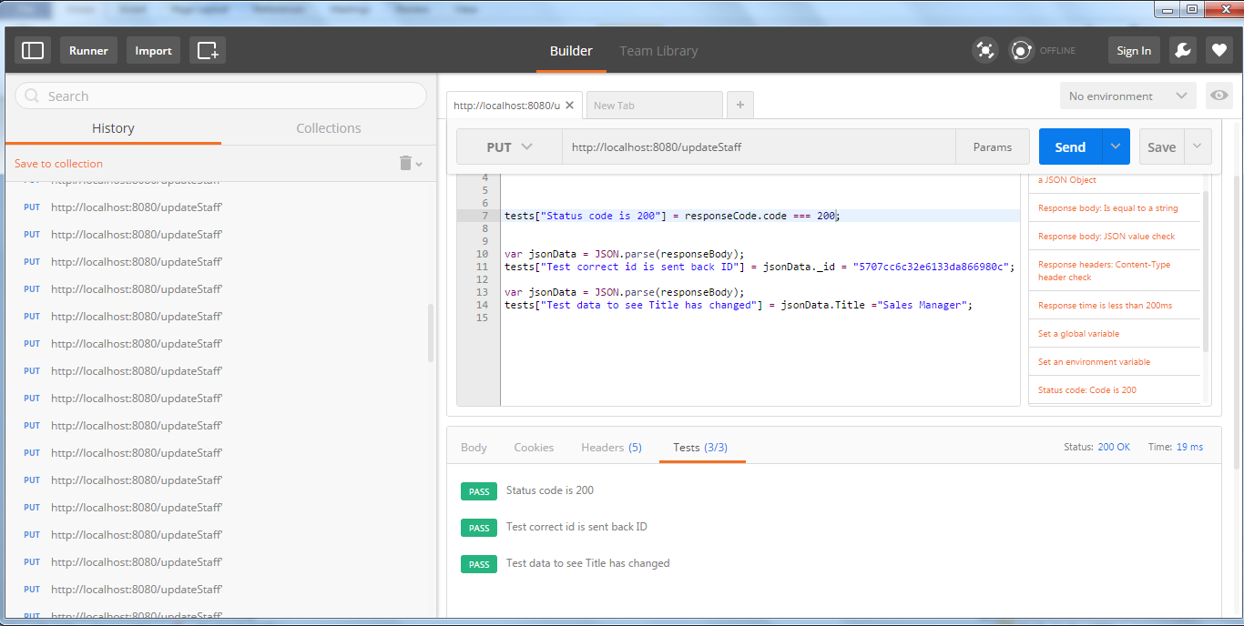

**http body**

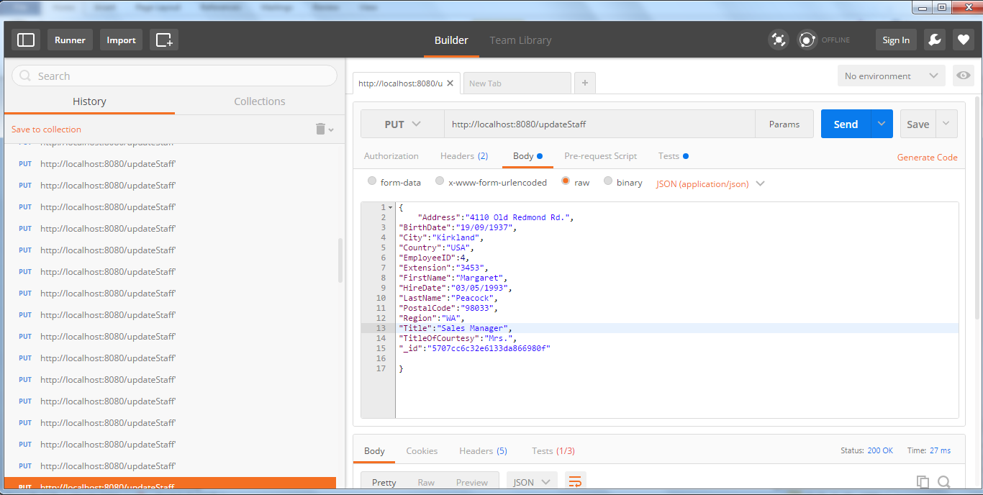

Test 1: **Result**

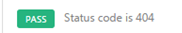

Test 2: **Result**



**Test Title:** Test to post http request on api

**Test Description**

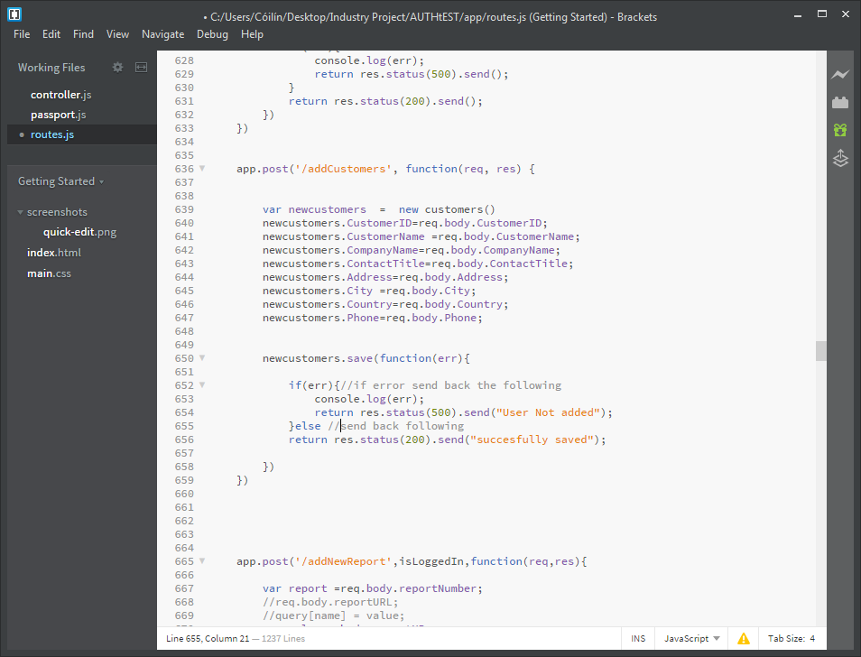

This test was created to assure that the correct response is returned from the above api. The above api take json data in the body of a post http request and tries to save the object to the mongodb.

**Test 1**: Test that the api sends back a 200 status sent and the String successful is sent back in the body

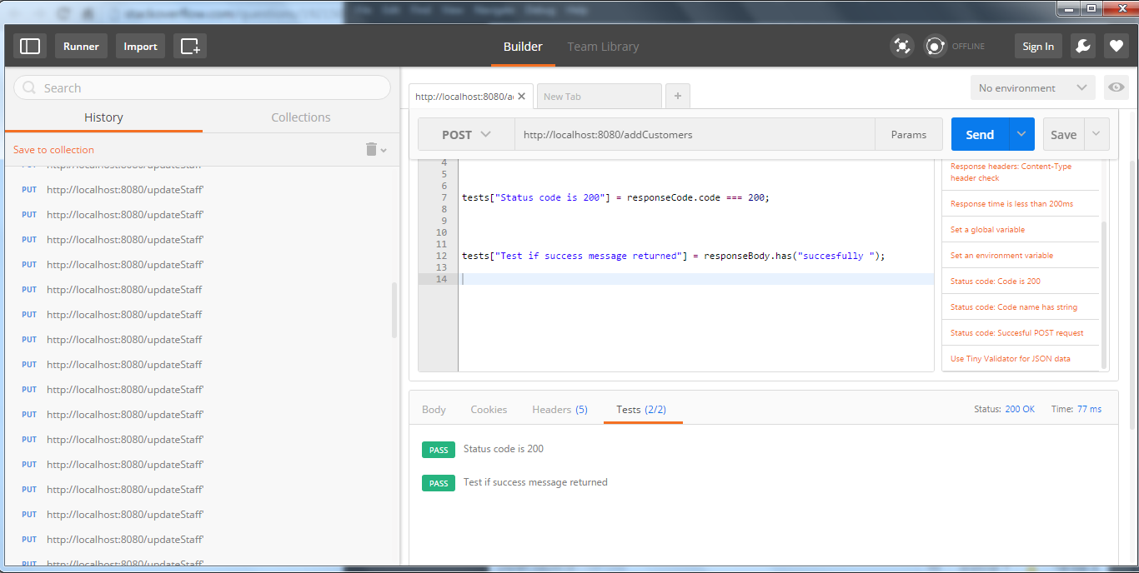



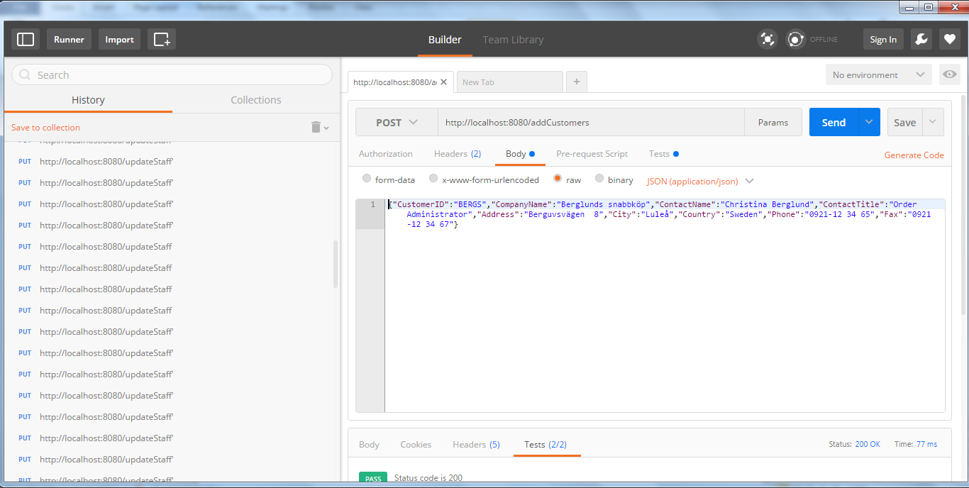

**Test Title:** Test to delete http request on api

**Test Description**

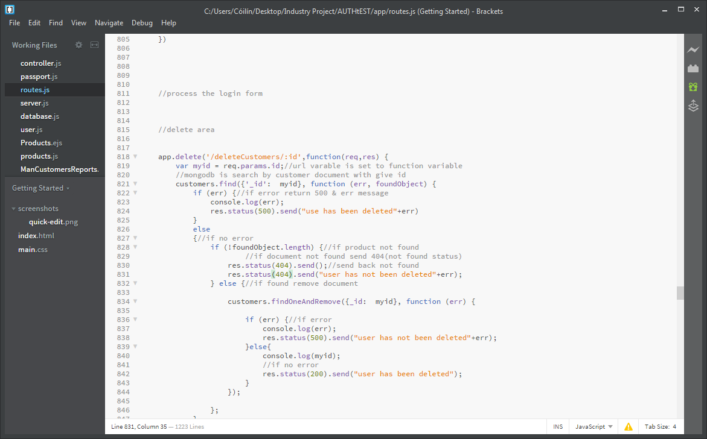

This test was created to assure that the correct response is returned from the above api. The above api takes an id value from the url and searches the Mongodb for matching document which it then tries to delete.

**Test 1:** Test if the correct id is sent to the api that a 200 status sent and the String “use has been deleted” is sent back in the body of the response.

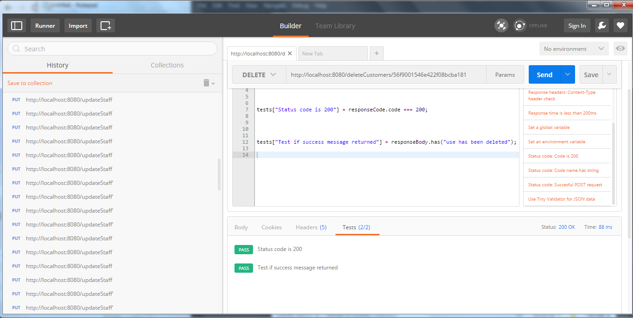

**Test 2:** Test if the correct id is sent to the api that a 500 status sent and the String “use has not been delete” is sent back in the body of the response.

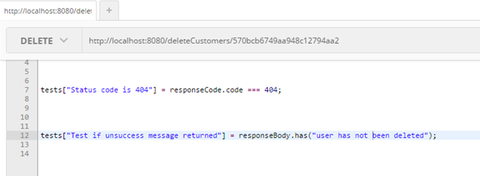

**Test 1: Result**



Test 1: Result

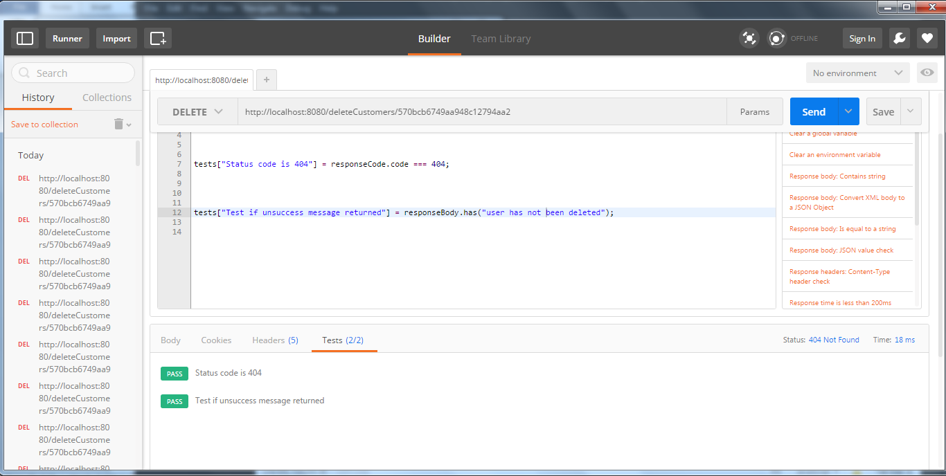

# Technologies Used

1. GitHub
2. Docker
3. Virtual Machine concepts
4. Putty
5. WinSCP
6. Private and public key authentication
7. Postman
8. JSON Data
9. VMC design concept
10. Ubuntu
11. NoSQL
12. RoboMongo
13. API’s
14. Single Page Applications
15. Bootstrap
16. D3.js

# Use Case

# Story Boards

# Design Pattern

# Development Life Cycle Methodology

# System Design:

# System Overview:

# Devolvement Practises & Processes

Ke

# General Constraints:

# Future development

* “Become familiar with AWS (Amazon web Services)
* Create an Ubuntu instance on EC2 and become familiar with Ubuntu OS.
* Create a web application on an Ubuntu EC2 instance will be built using the MEAN stack (MongoDB, Express.js, Angular.js, Node.js).
* Creation of RESTful APIs on the backend using Express (Node.js) which will read from the MongoDB database and carry out analytics.
* Use Angular.js to make client side calls to the server side APIs which return JSON data and display the data on the client.”

And from the above list of technologies I drew up the following project outline

I believe not only have I incorporated the above technologies and created the required web application I have also surpassed the above outline in functionality and technologies used. The purpose of which were to including more technologies in which AltoCloud uses on a daily basis to lessen the jump from university to my internship. And use software that is commonly used in industry that would complement the project and widen its scope.

Now that the problem definition has be solved and surpassed in technologies used and requirements outlined , we can use the software purpose outline below to define the solution to the problem definition.